Which statements about the following code are correct?

Var data = List.of(2, 5, …)

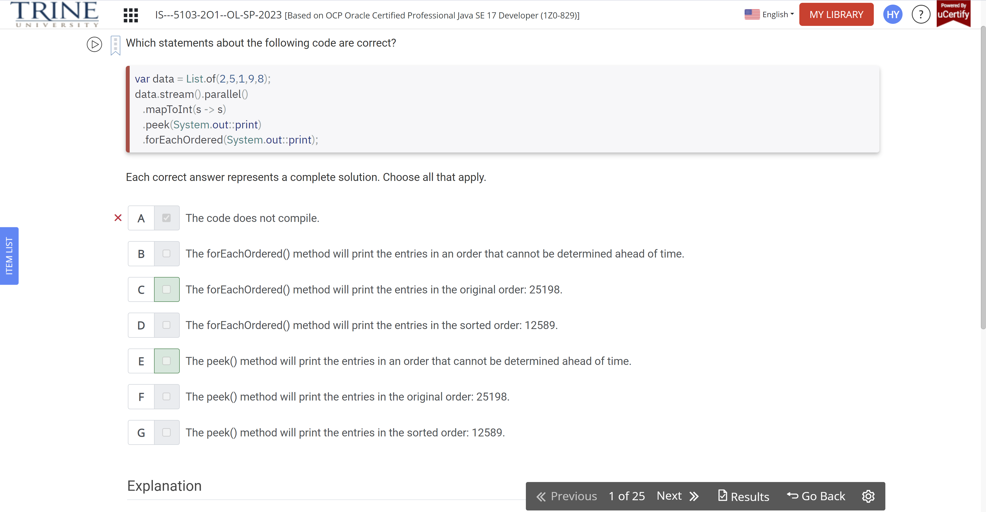

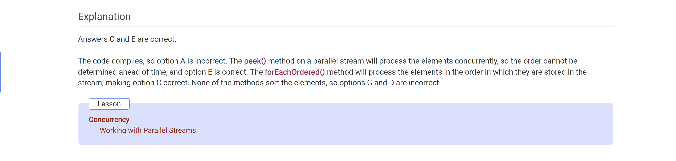

Assuming an implementation of the performCount() method is …

Public class CountZooAnimals …

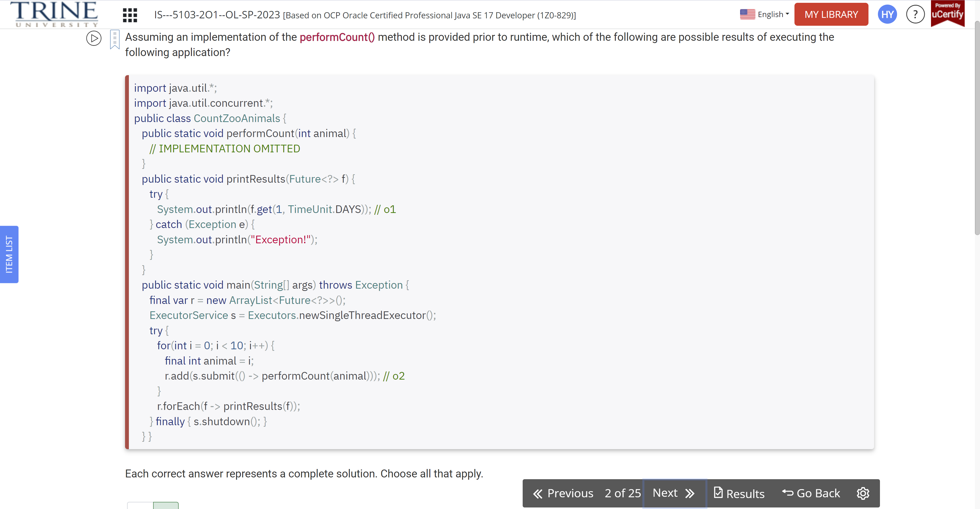

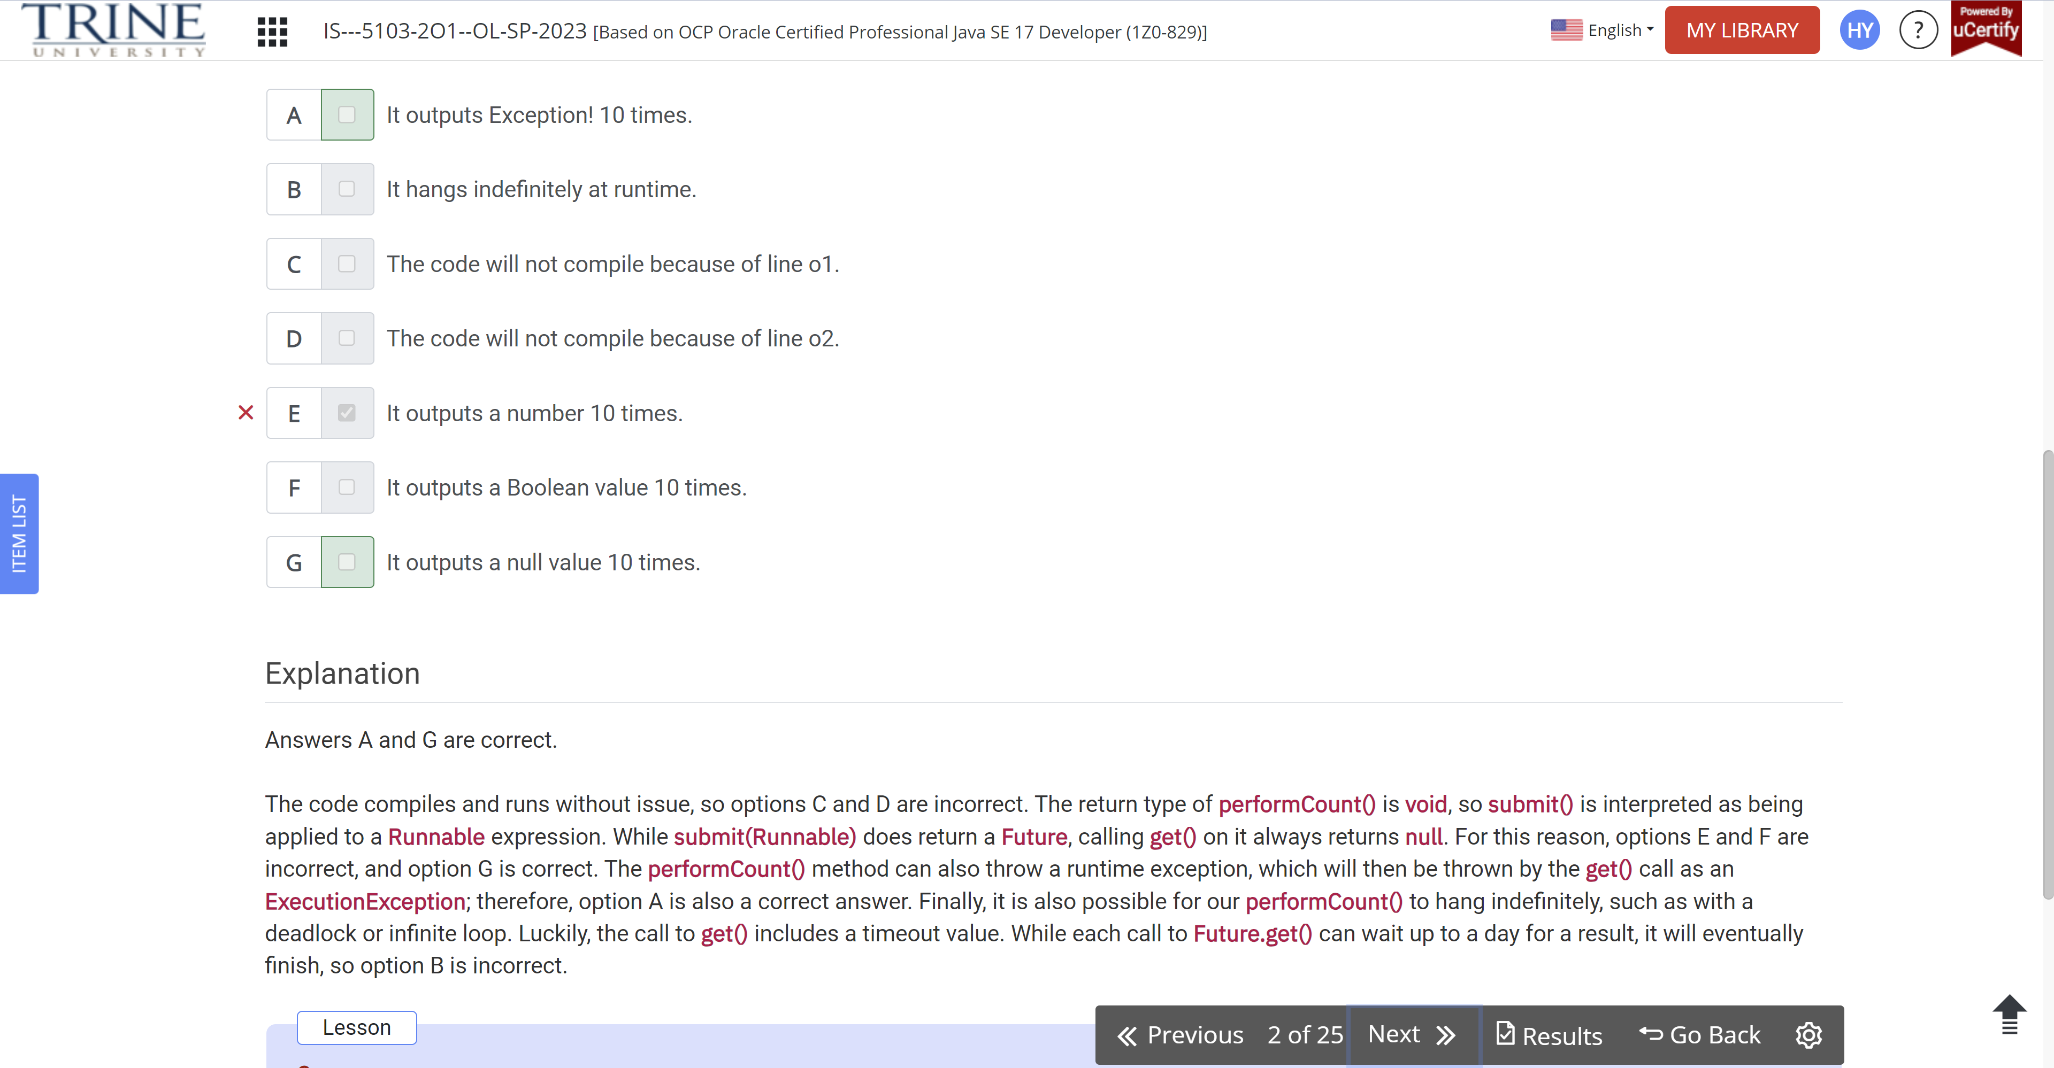

What are the results of executing the following code?

Public class PrintConstants…

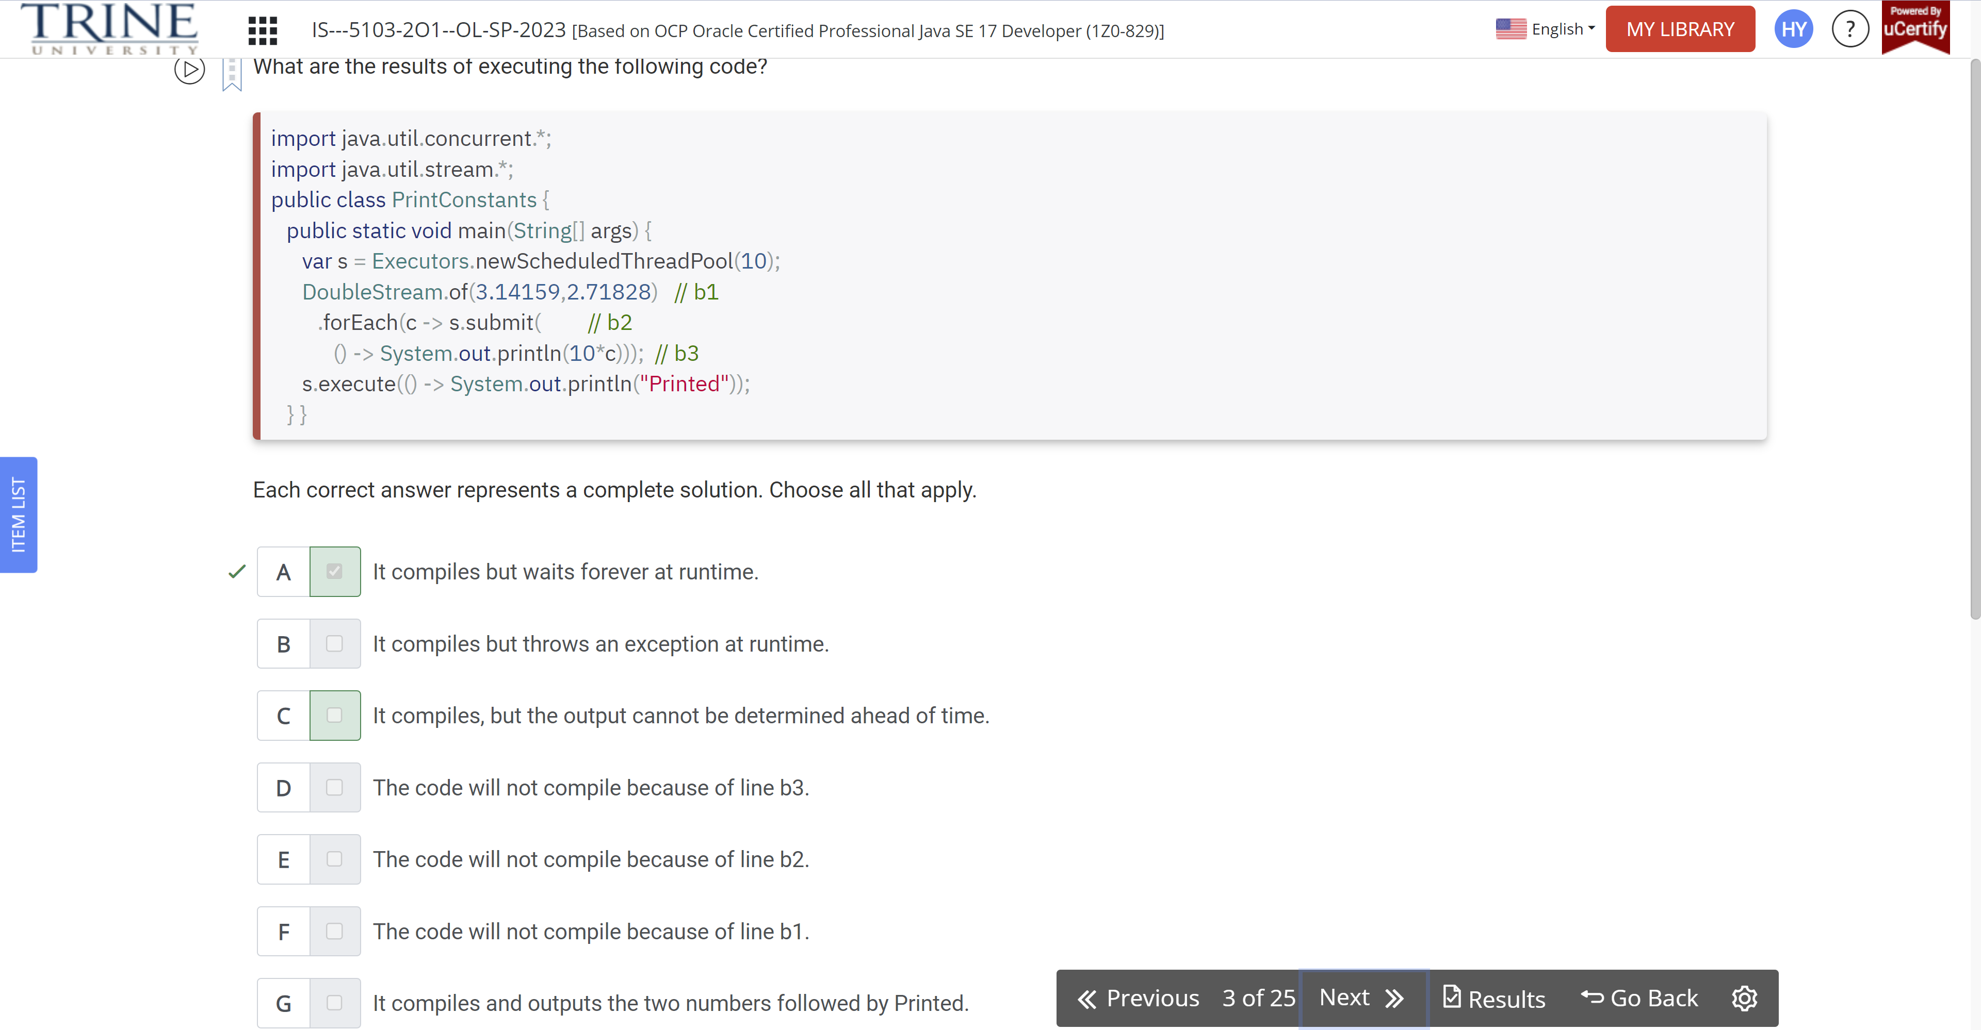

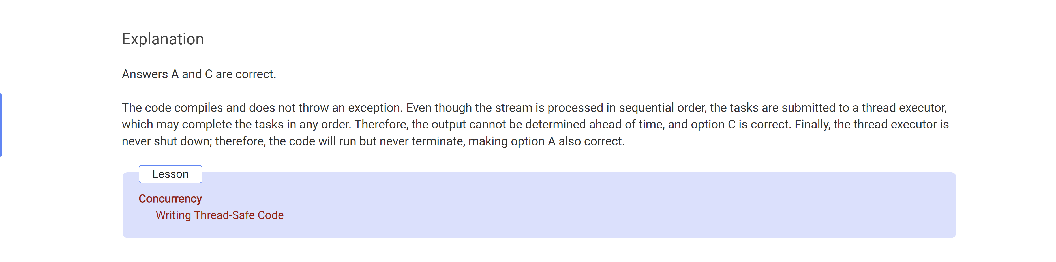

What statement about the following code is true?

System.out.print(List.of(“duck”, …))

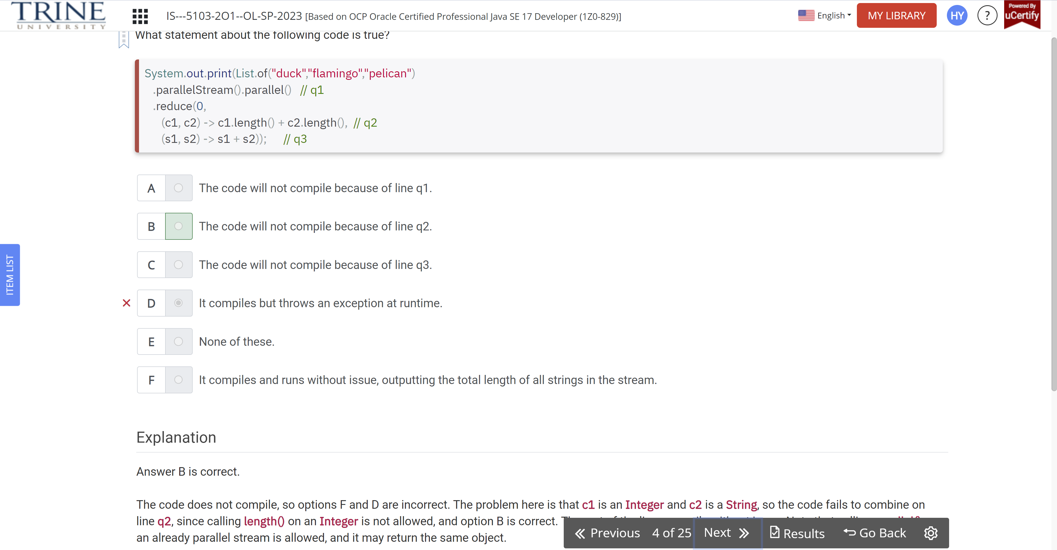

Given the following code snippet and blank lines on p1 and p2, which values guarantee that 1 is printed at runtime?

Var data = List.of(List.of(1, 2)),..

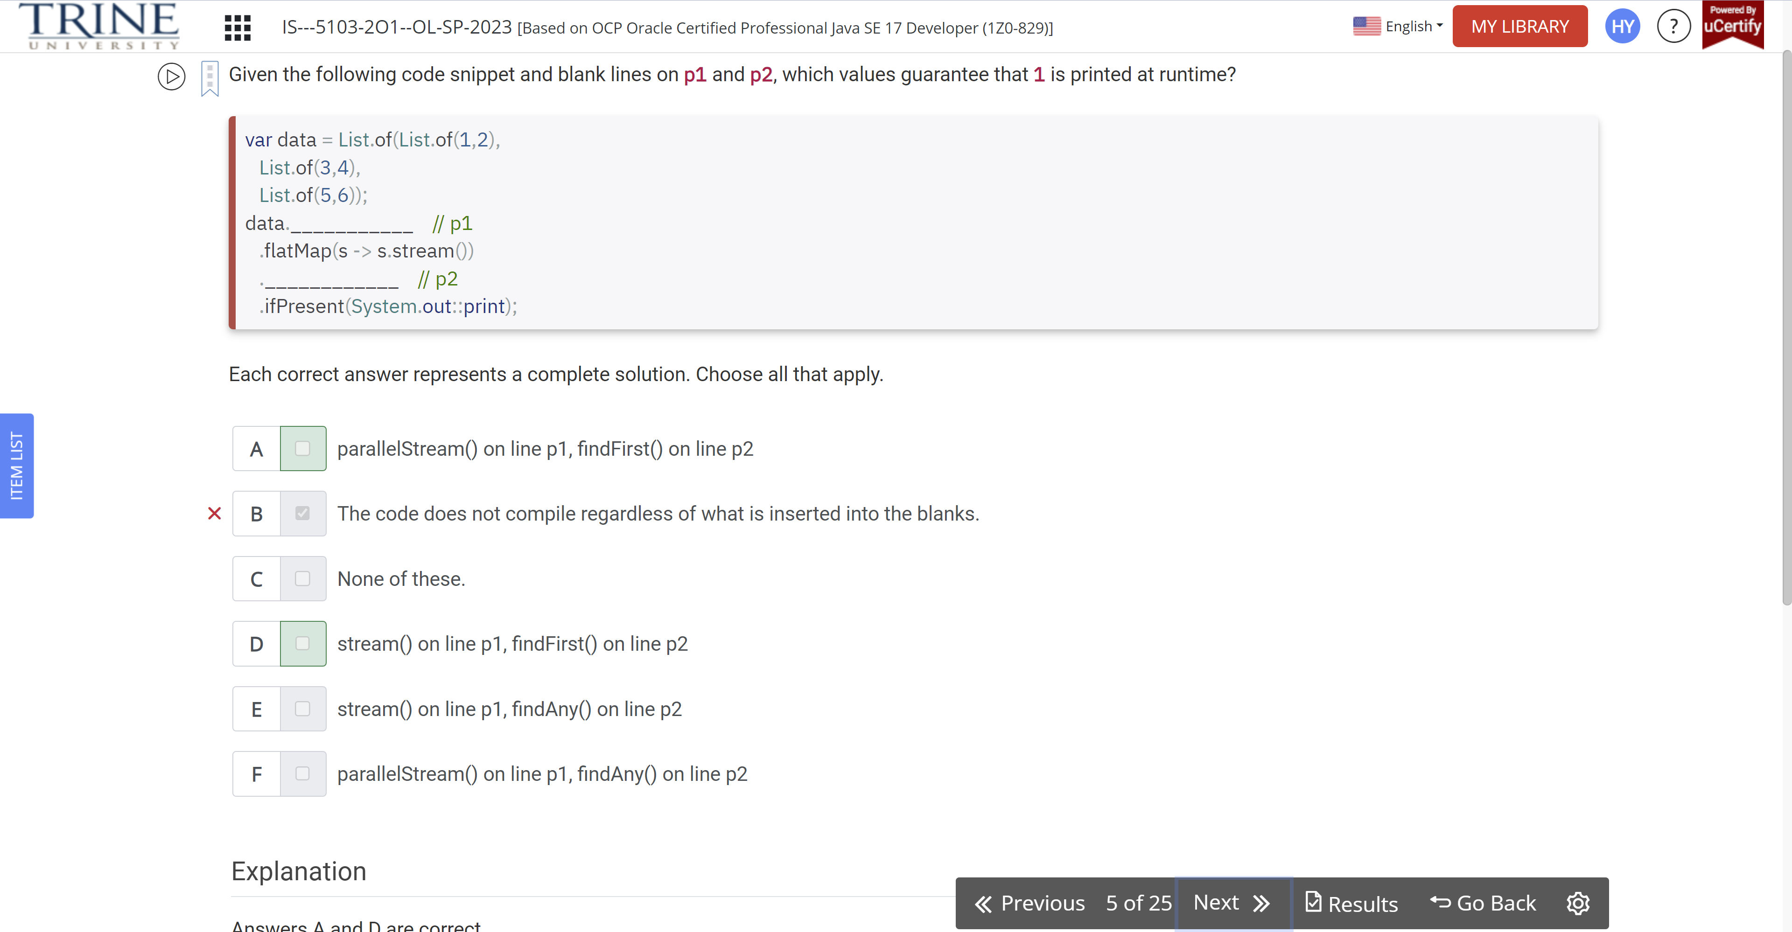

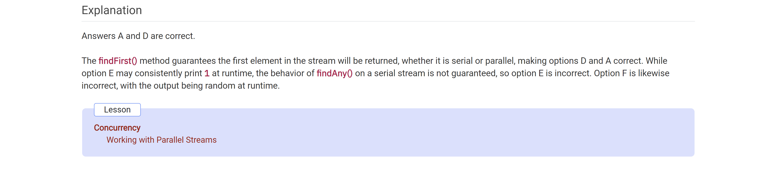

Fill in the blanks: Livelock occur(s) when two or more threads …

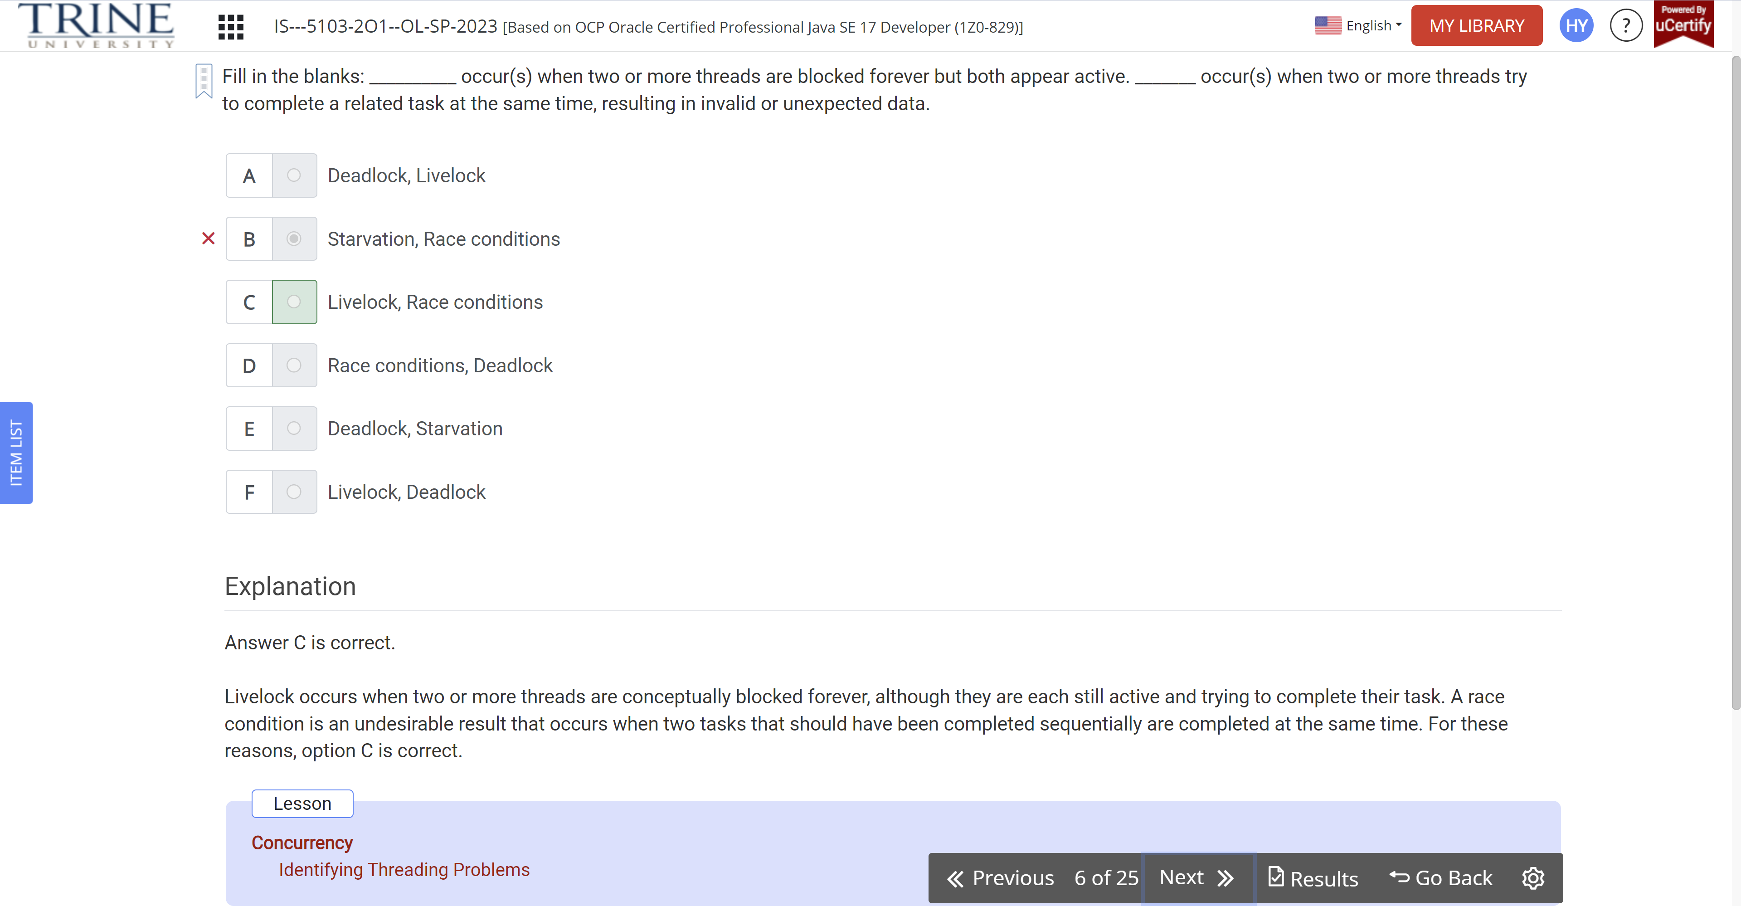

What is the result of executing the following code snippet?

List<Integer> lions = …

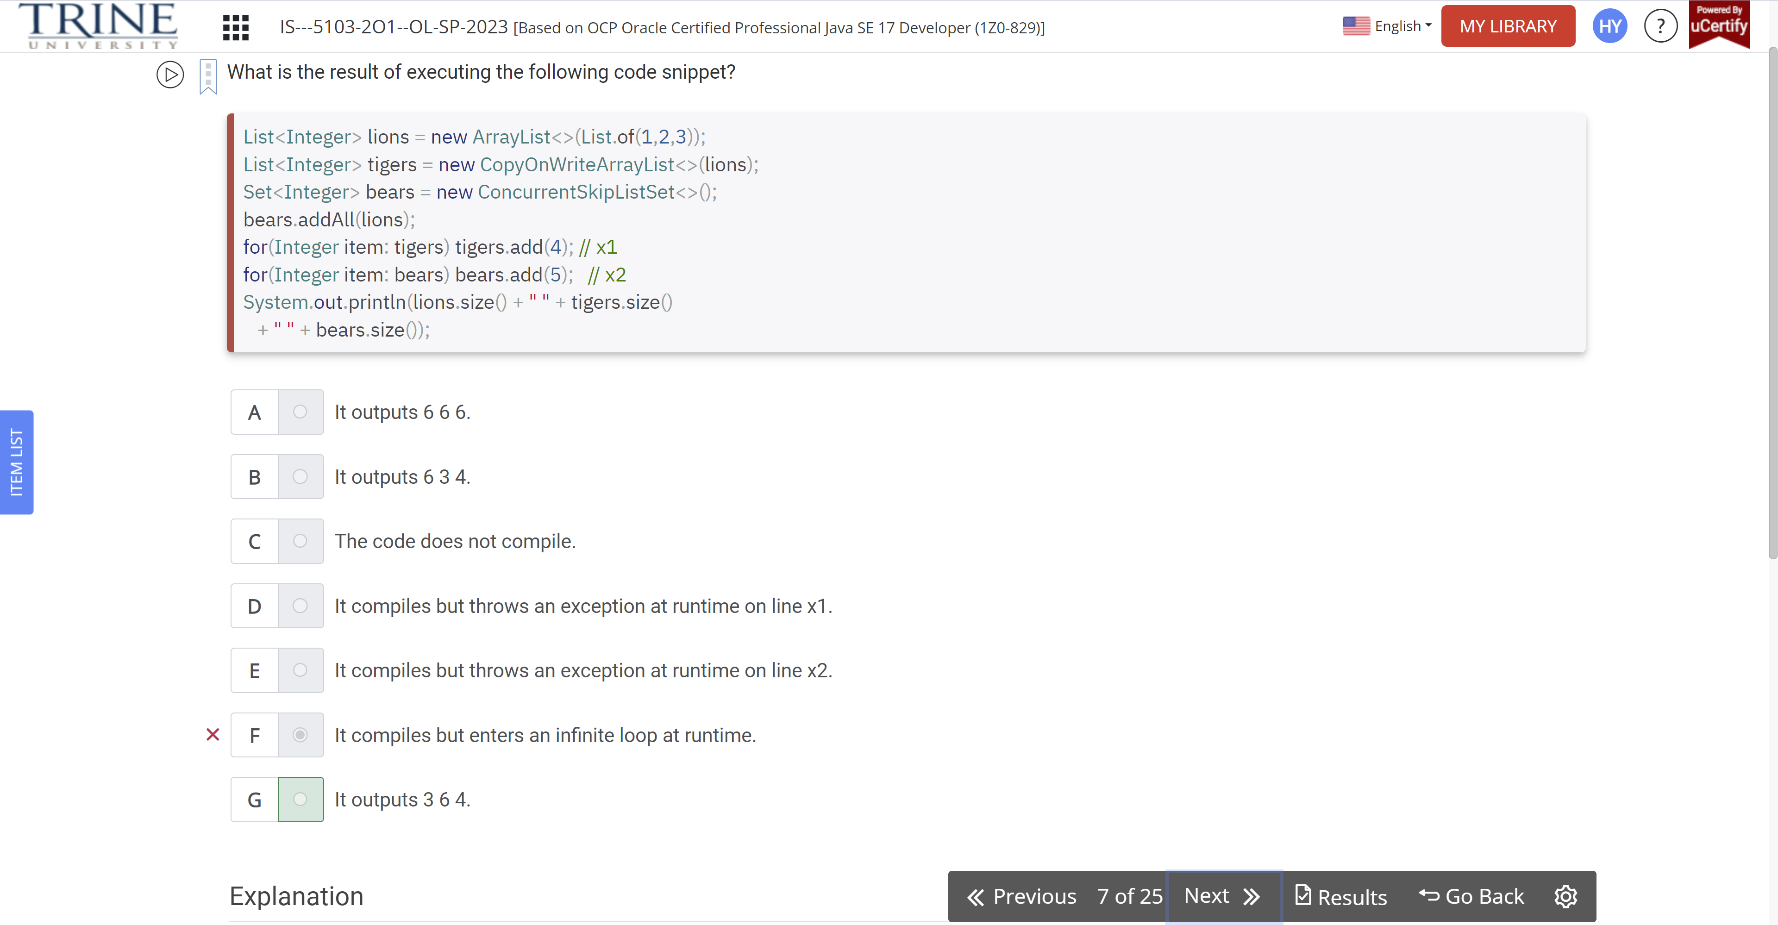

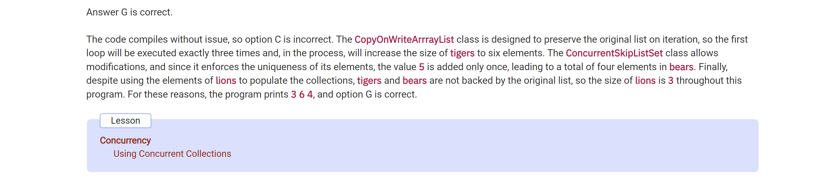

Which of the following are valid Callable expressions?

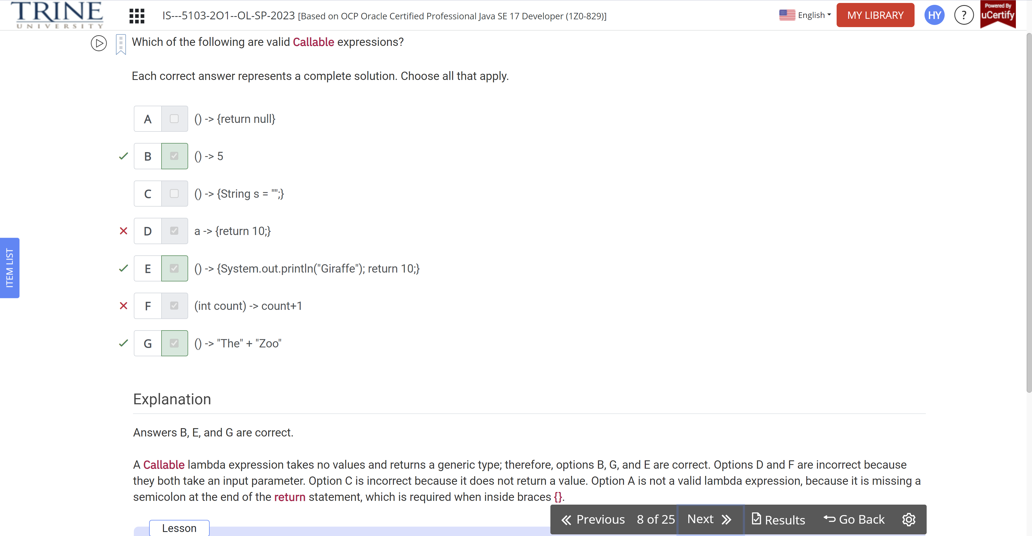

Assuming one minute is enough time for all the threads within this program to complete, …

Public class RocketShip…

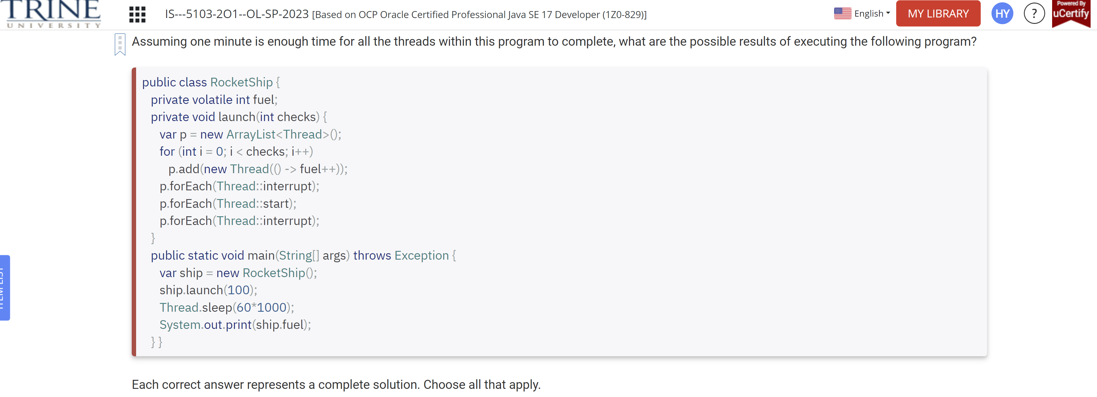

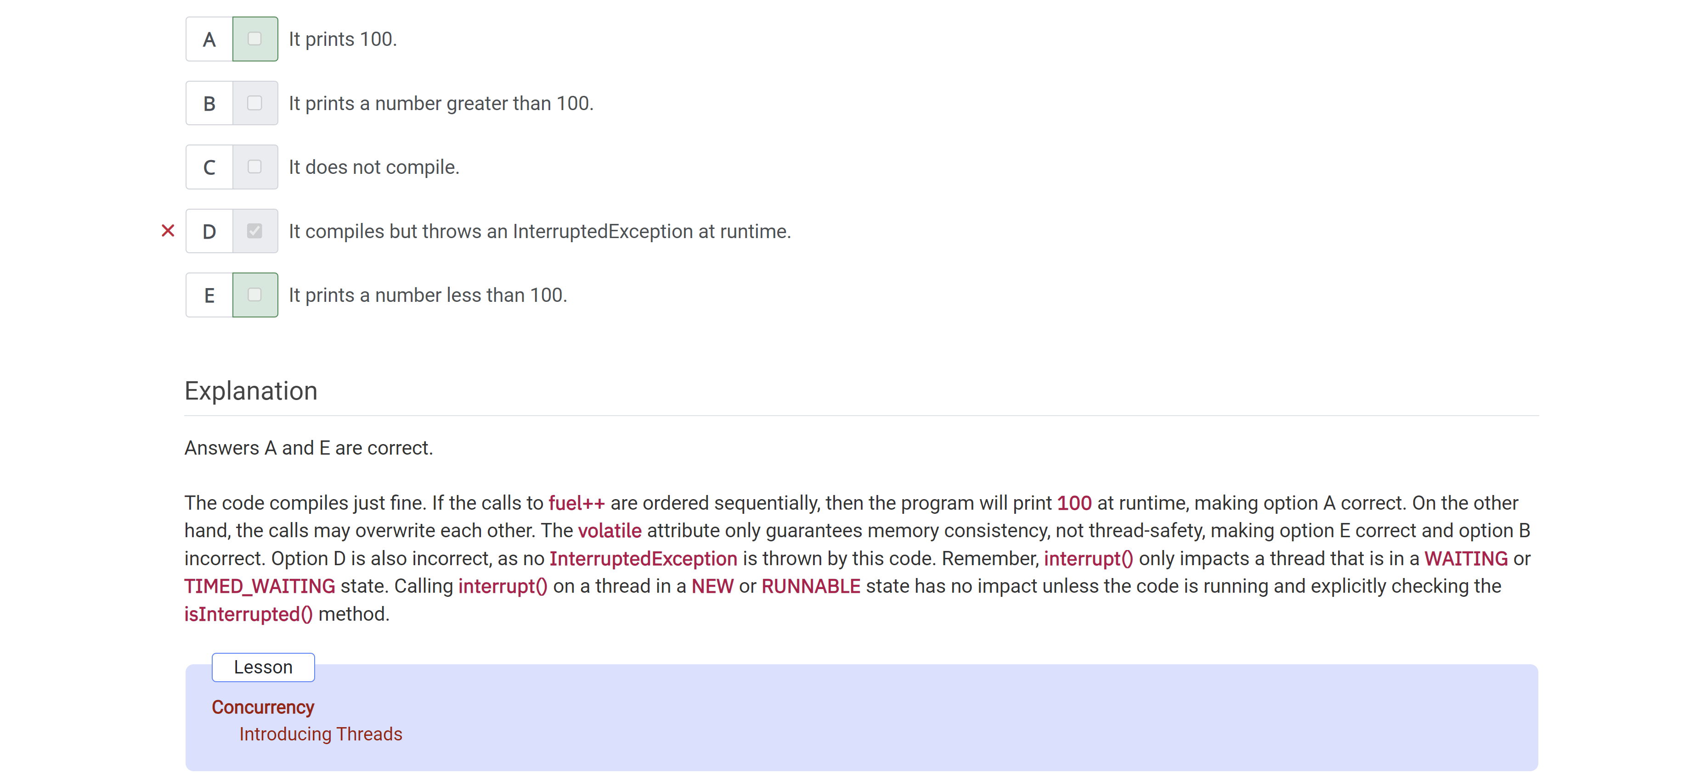What is the result of executing the following code?

Public class StockRoomTracker …

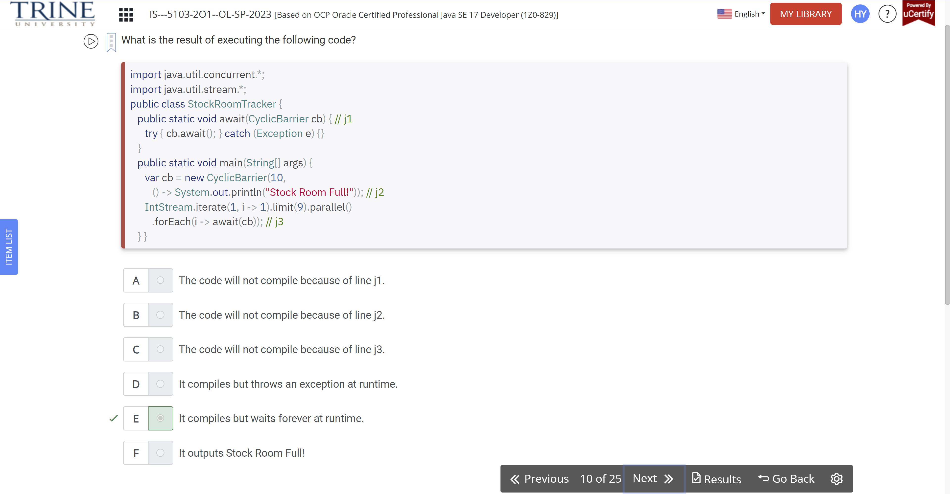

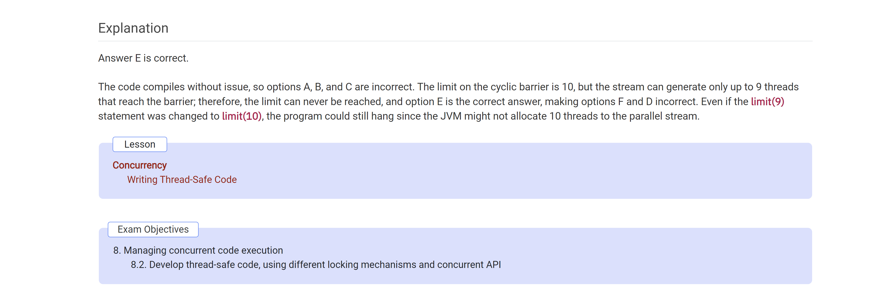

Given that the sum of the numbers from 1 (inclusive) to 10(exclusive) is 45, …

Public class Bank…

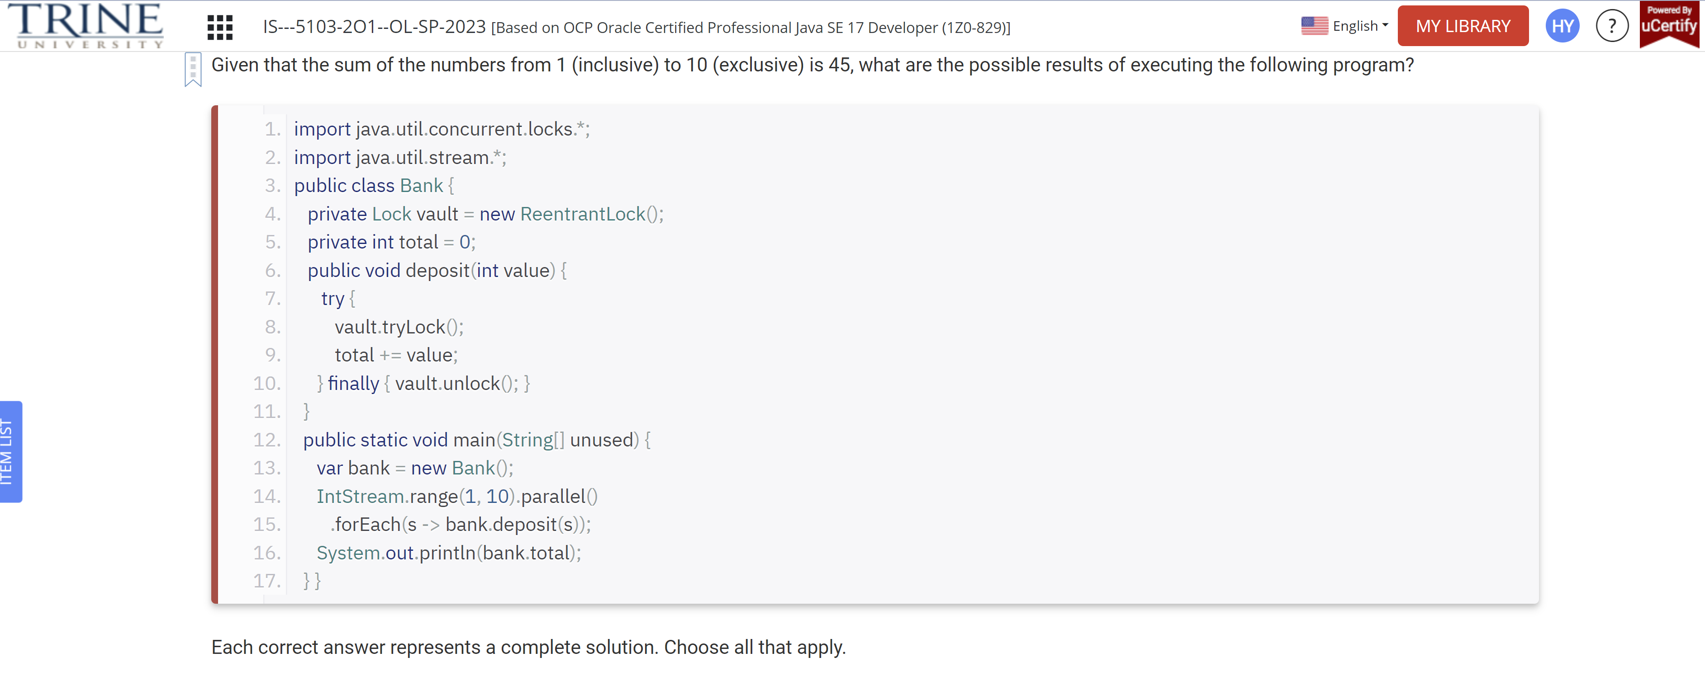

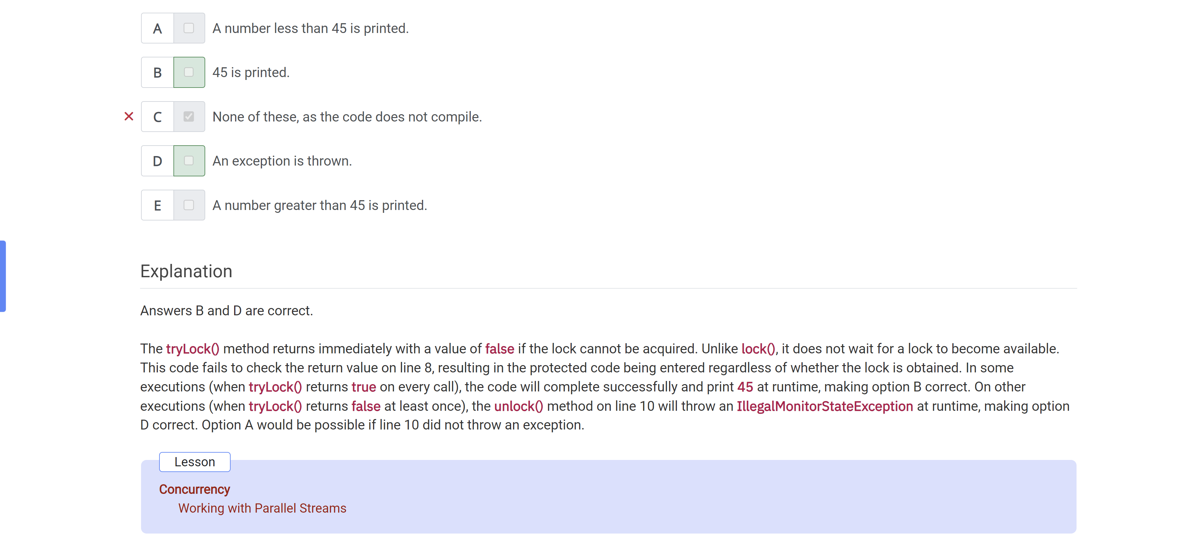

Given the following code snippet, which options …

Var c = new ArrayList…

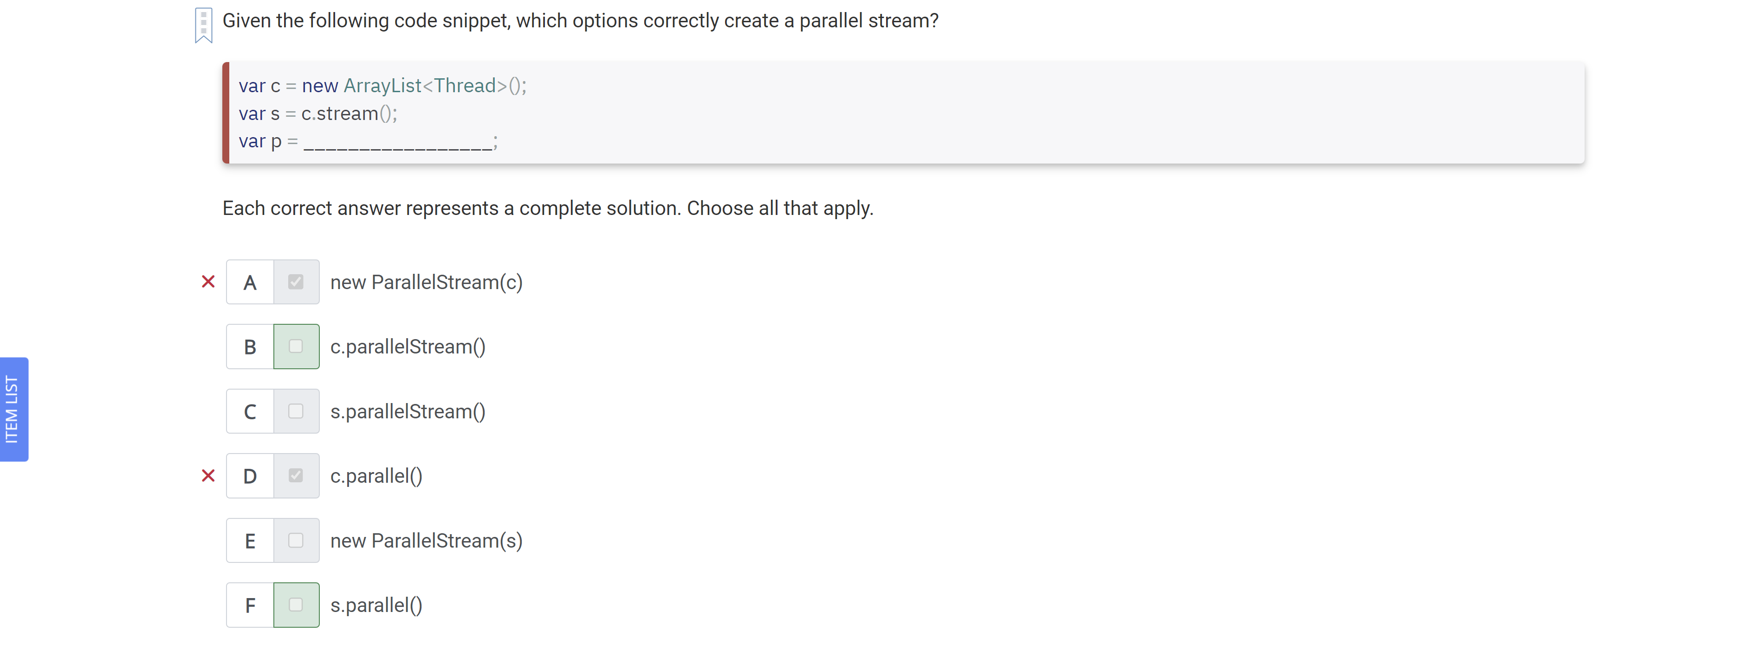

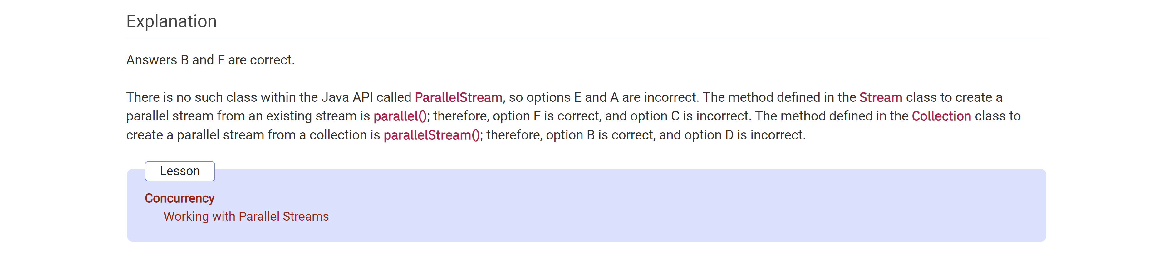

Assuming this class is accessed by only a single thread at a time, …countIceCreamFlavors()…

Public class Flavors…

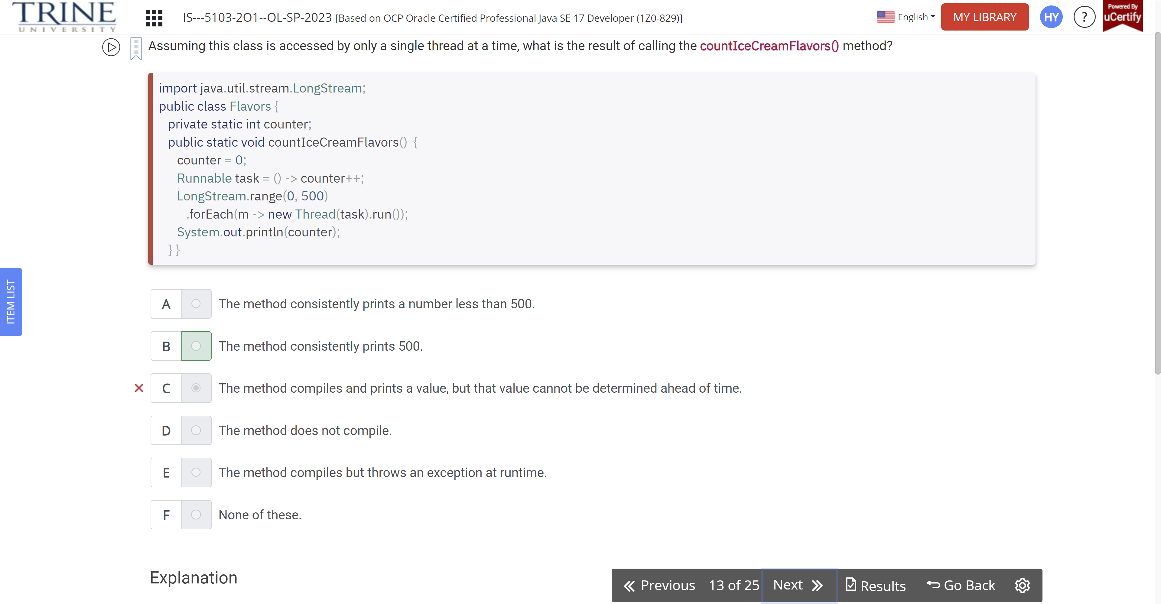

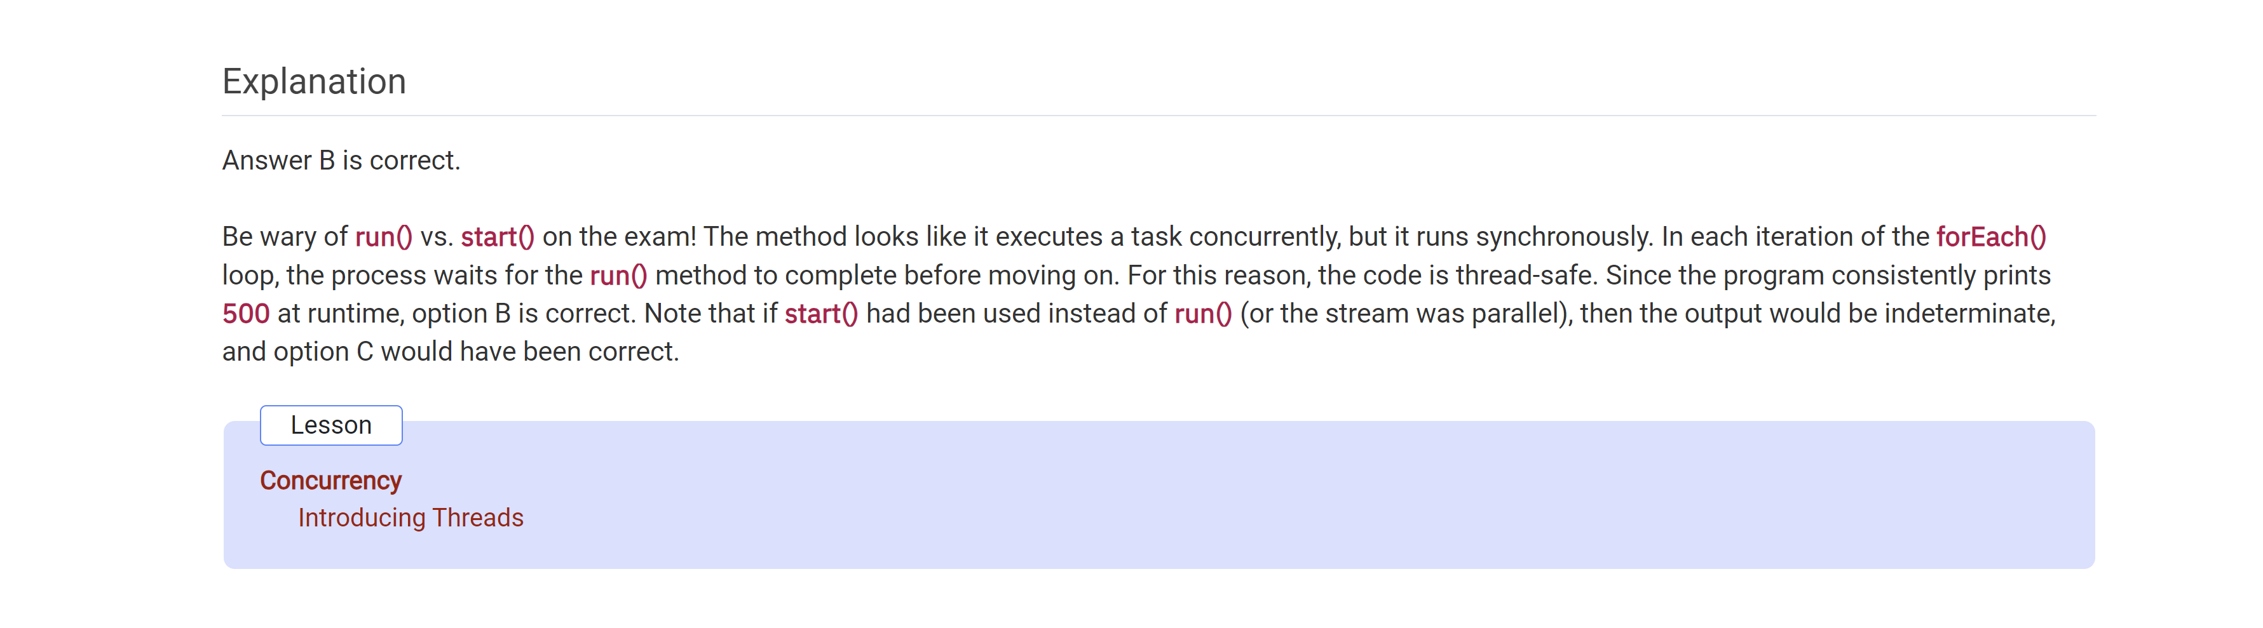

Which of the following statements about the Callable call() and Runnable run() methods are correct?

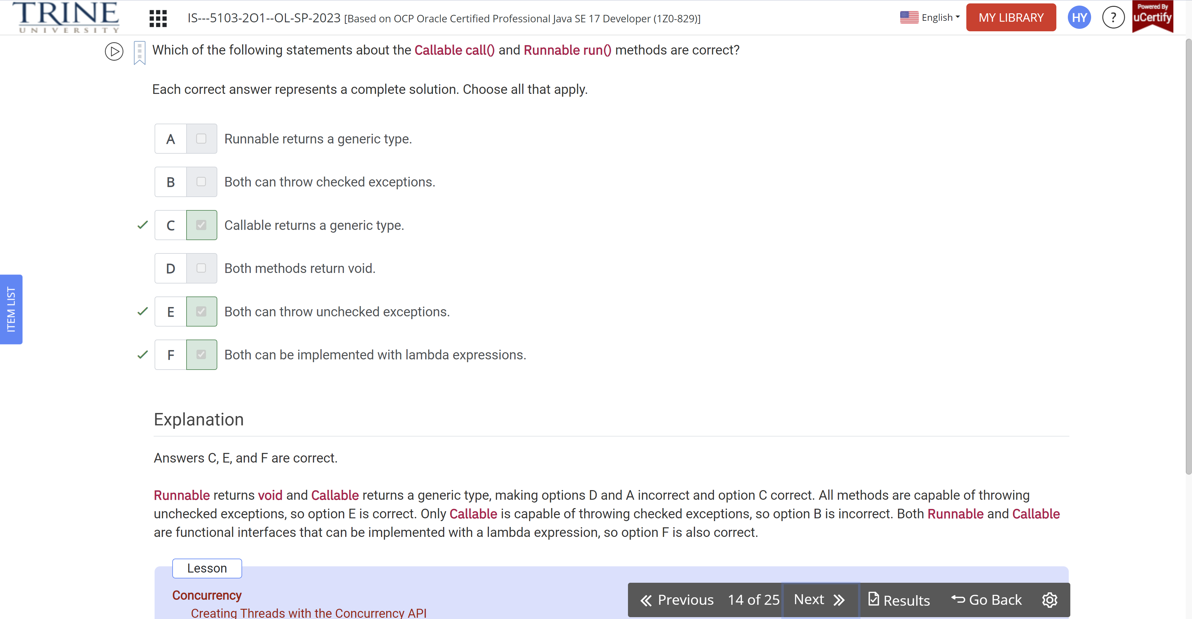

What statement about the following code is true?

Var value1 = new AtomicLong(0);

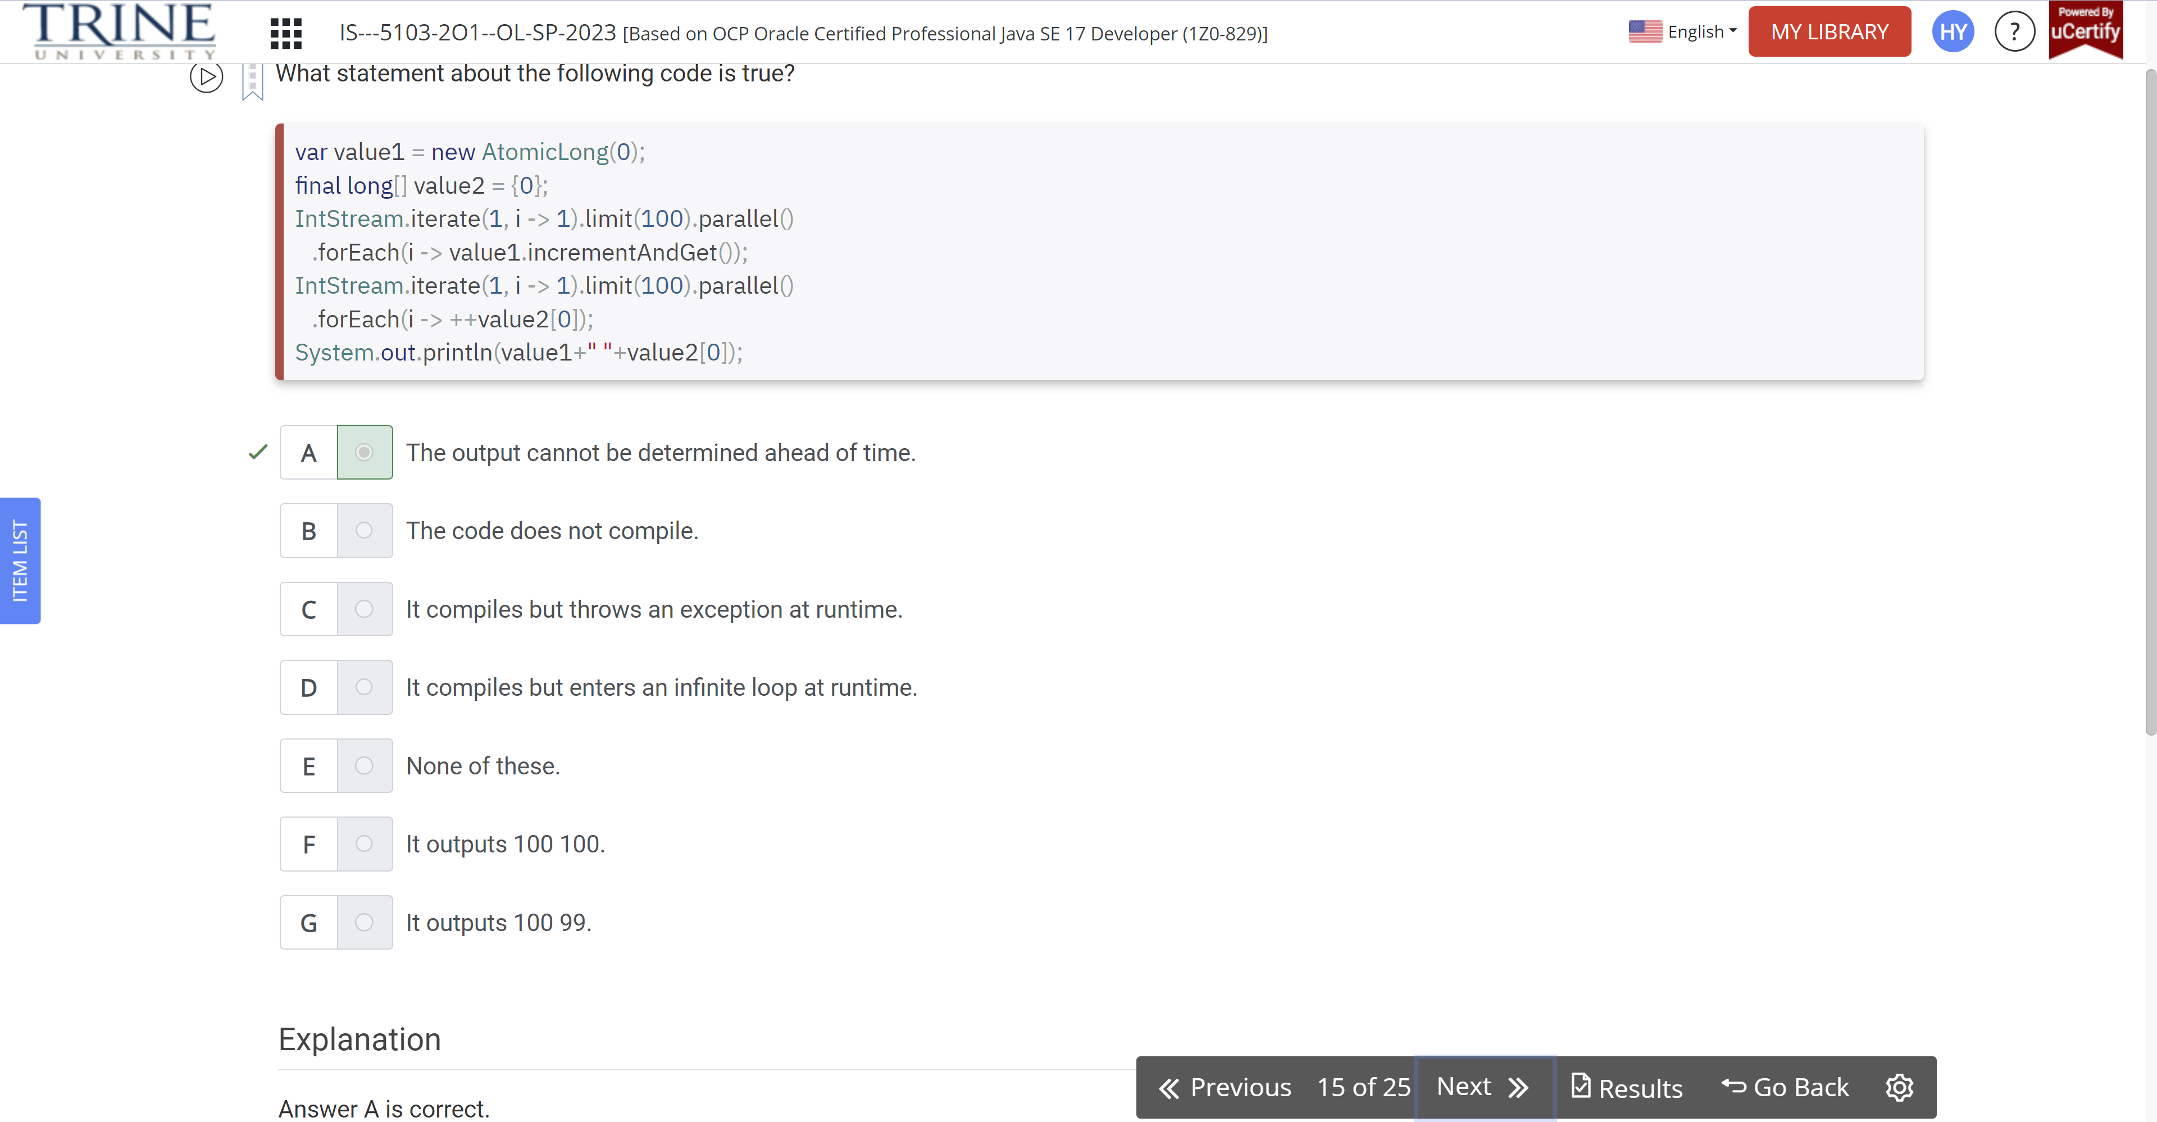

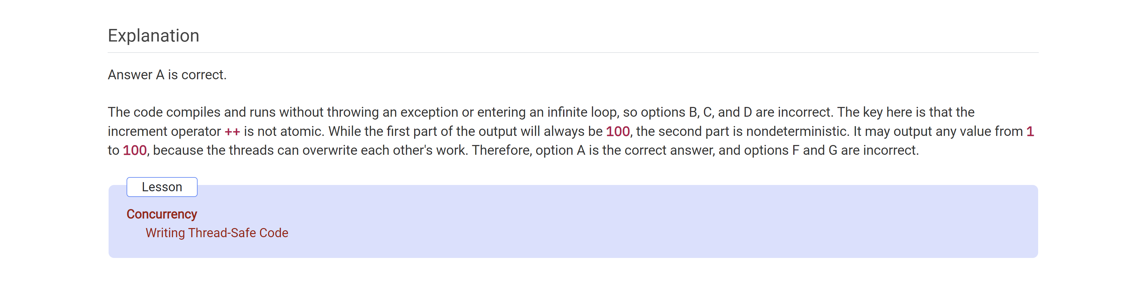

What is the result of executing the following program?

Public class PrintCounter…

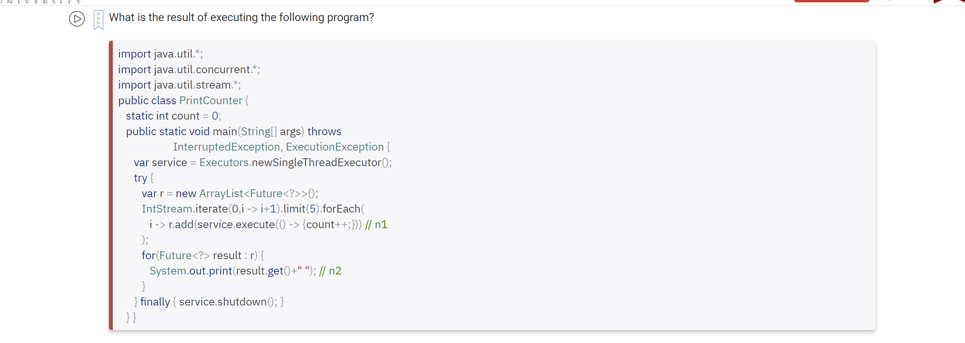

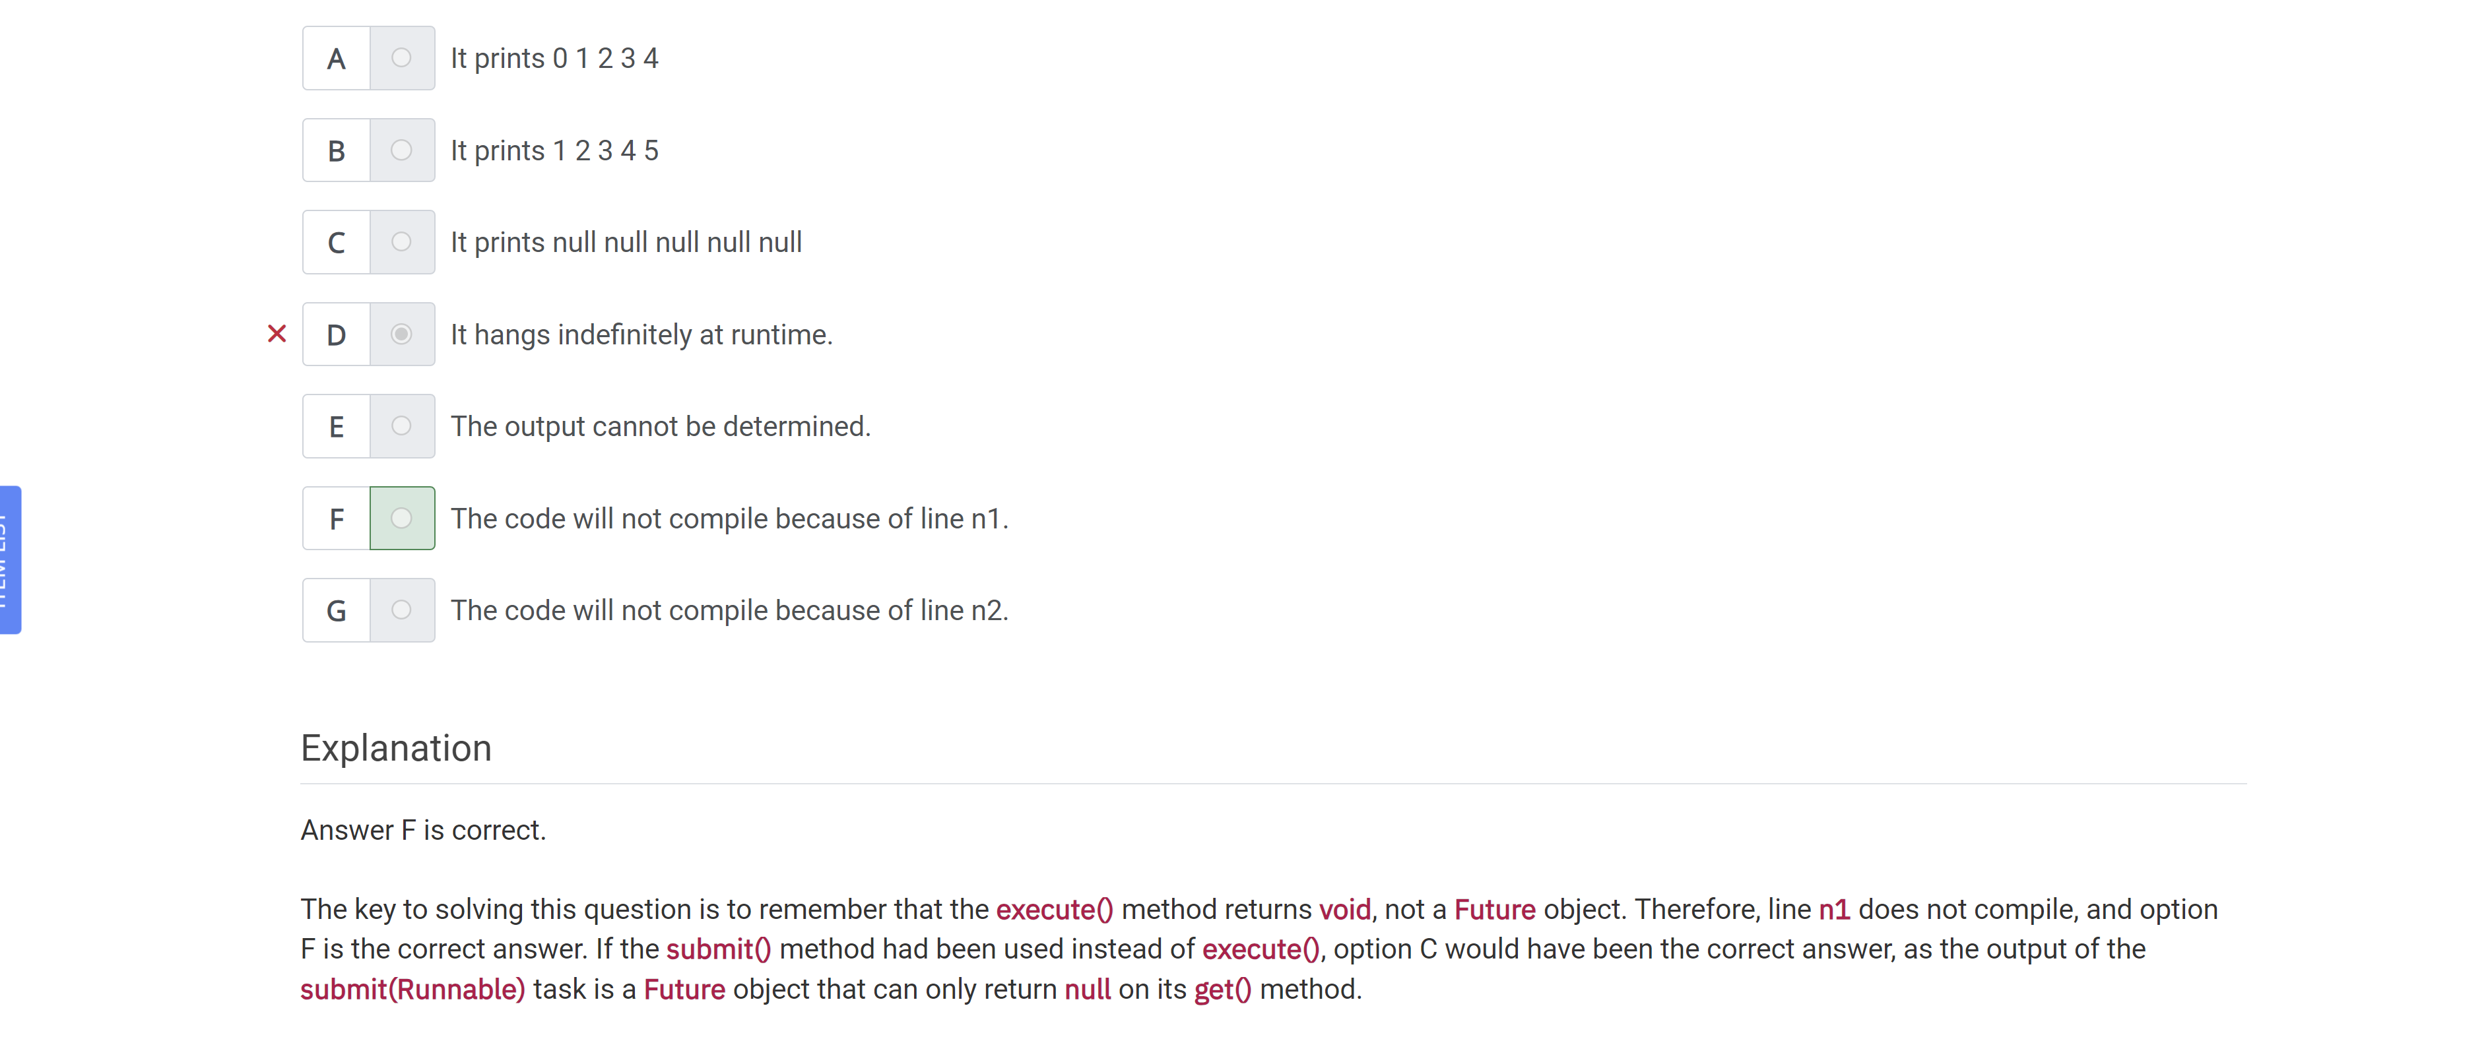

What statements about the following class definition are true?

Public final class TicketManager…

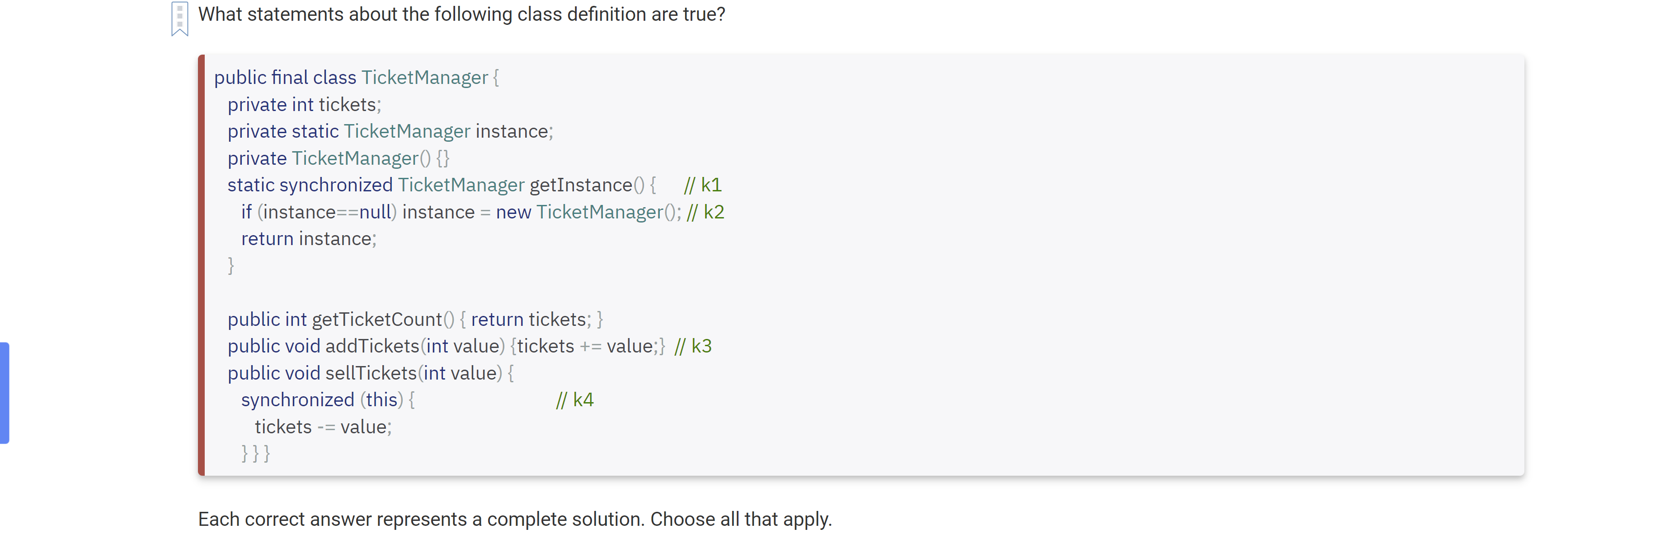

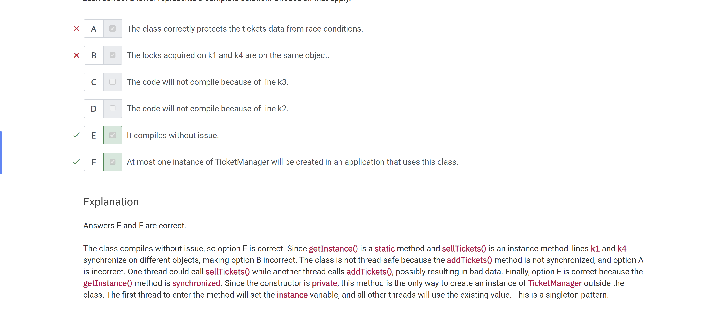

Which statement about methods in ReentrantLock is correct?

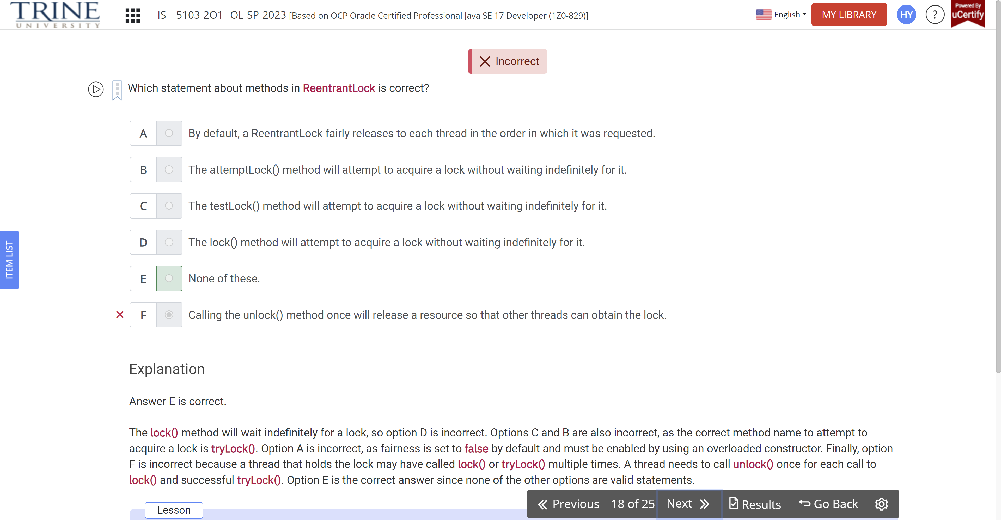

Which statement about the following code snippet is correct?

Var cats = Stream.of(….)

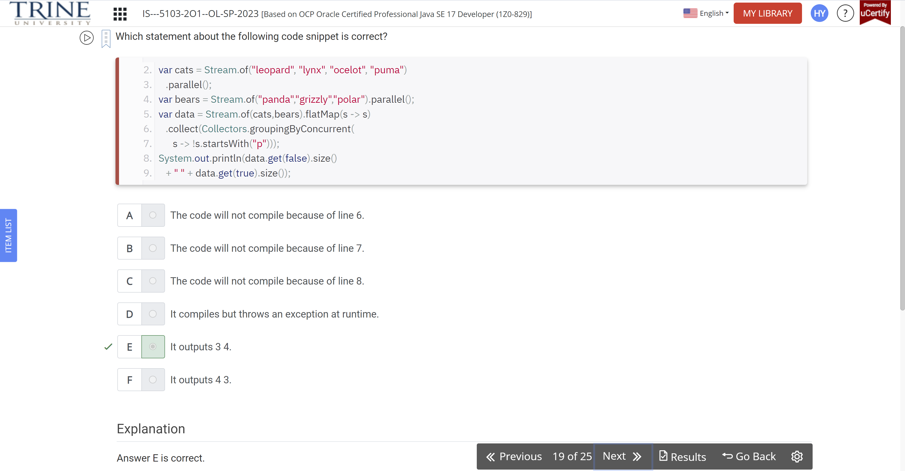

Which lines need to be changed to make the code compile?

ExecutorService service = // w1

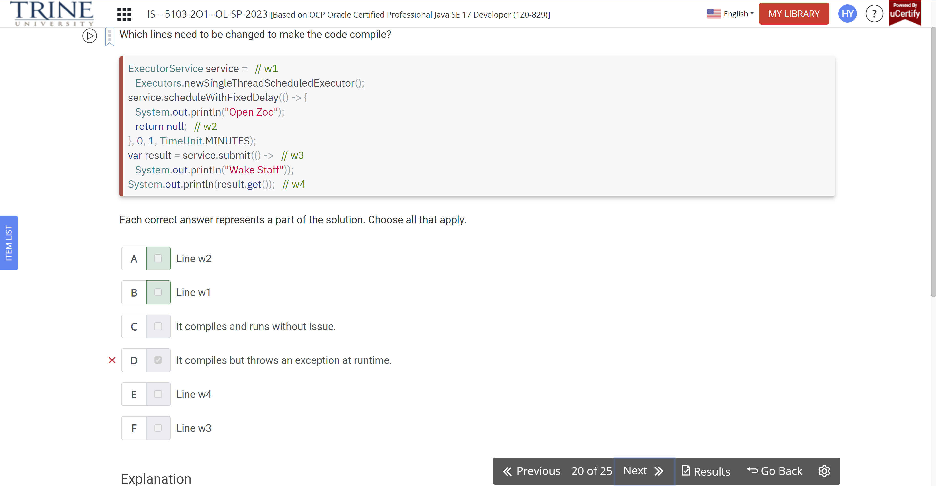

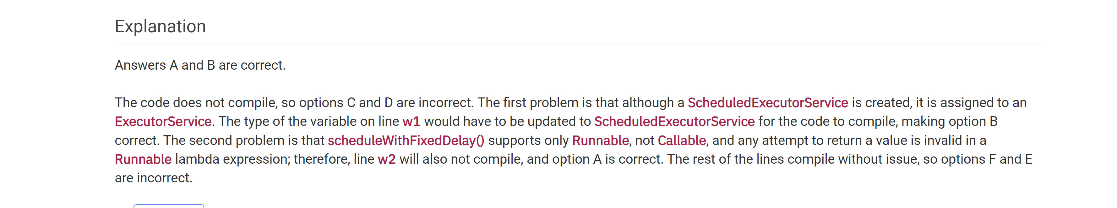

What happens when a new task is submitted to an ExecutorService in which no threads are available?

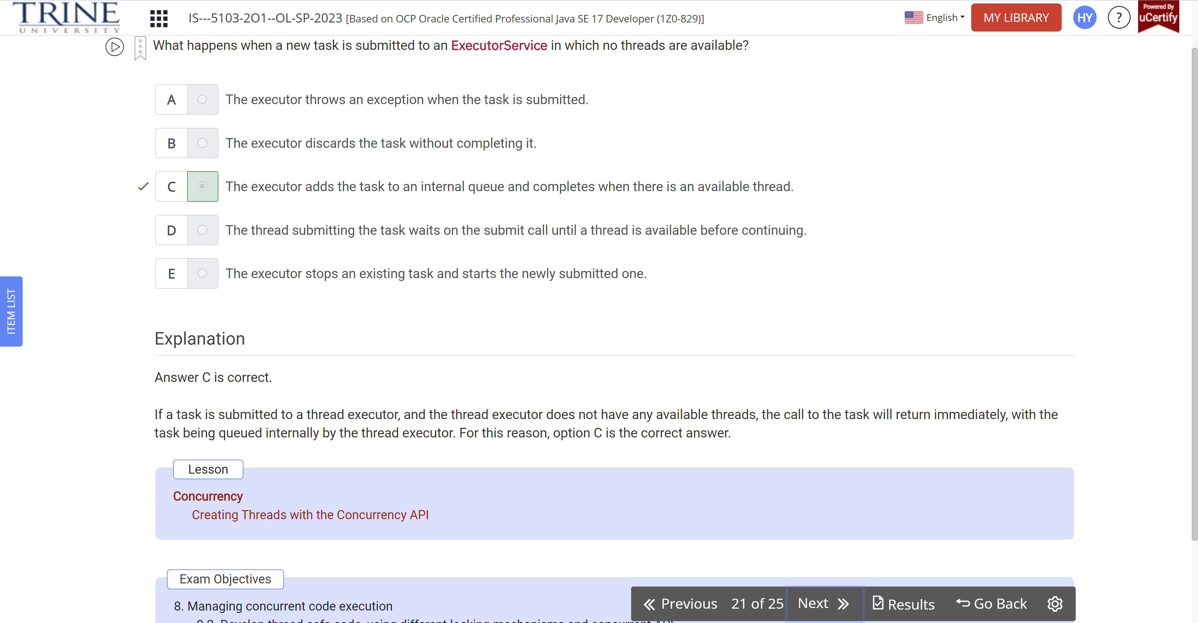

What statements about the following code snippet are true?

Object o1 = new Object()..

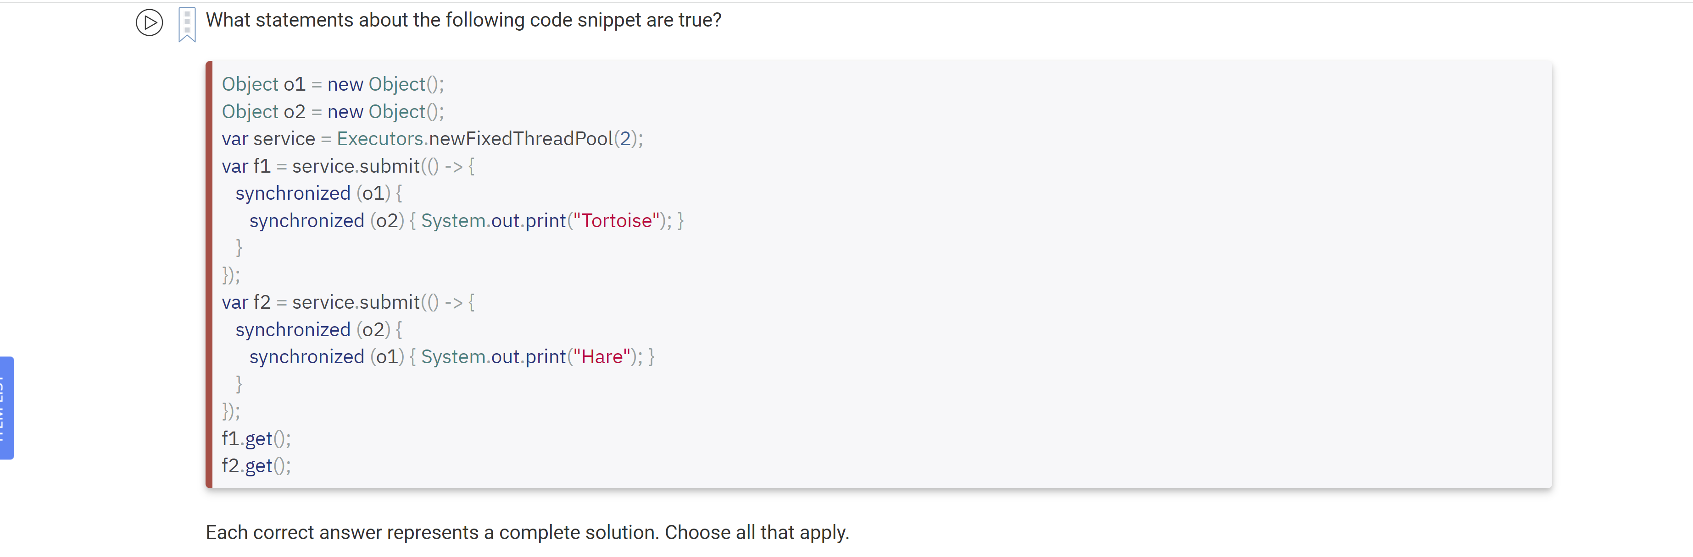

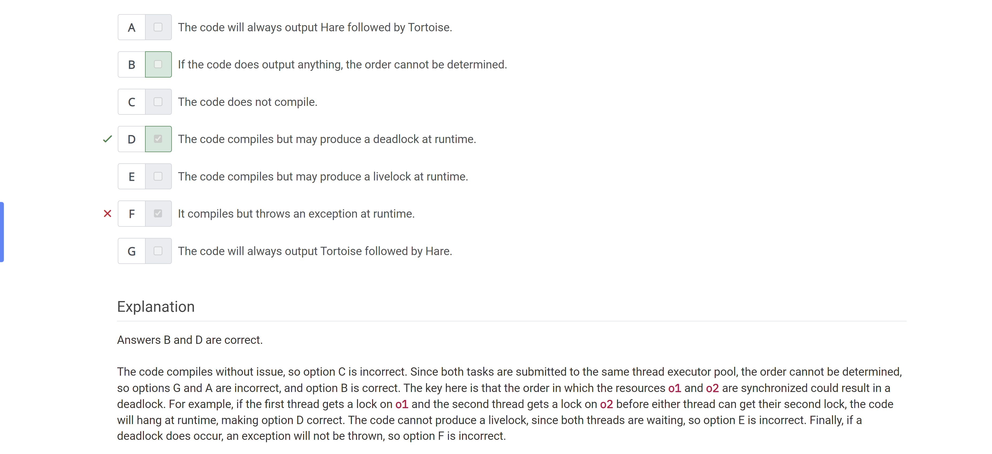

Assuming each call to takeNap() takes five seconds ….

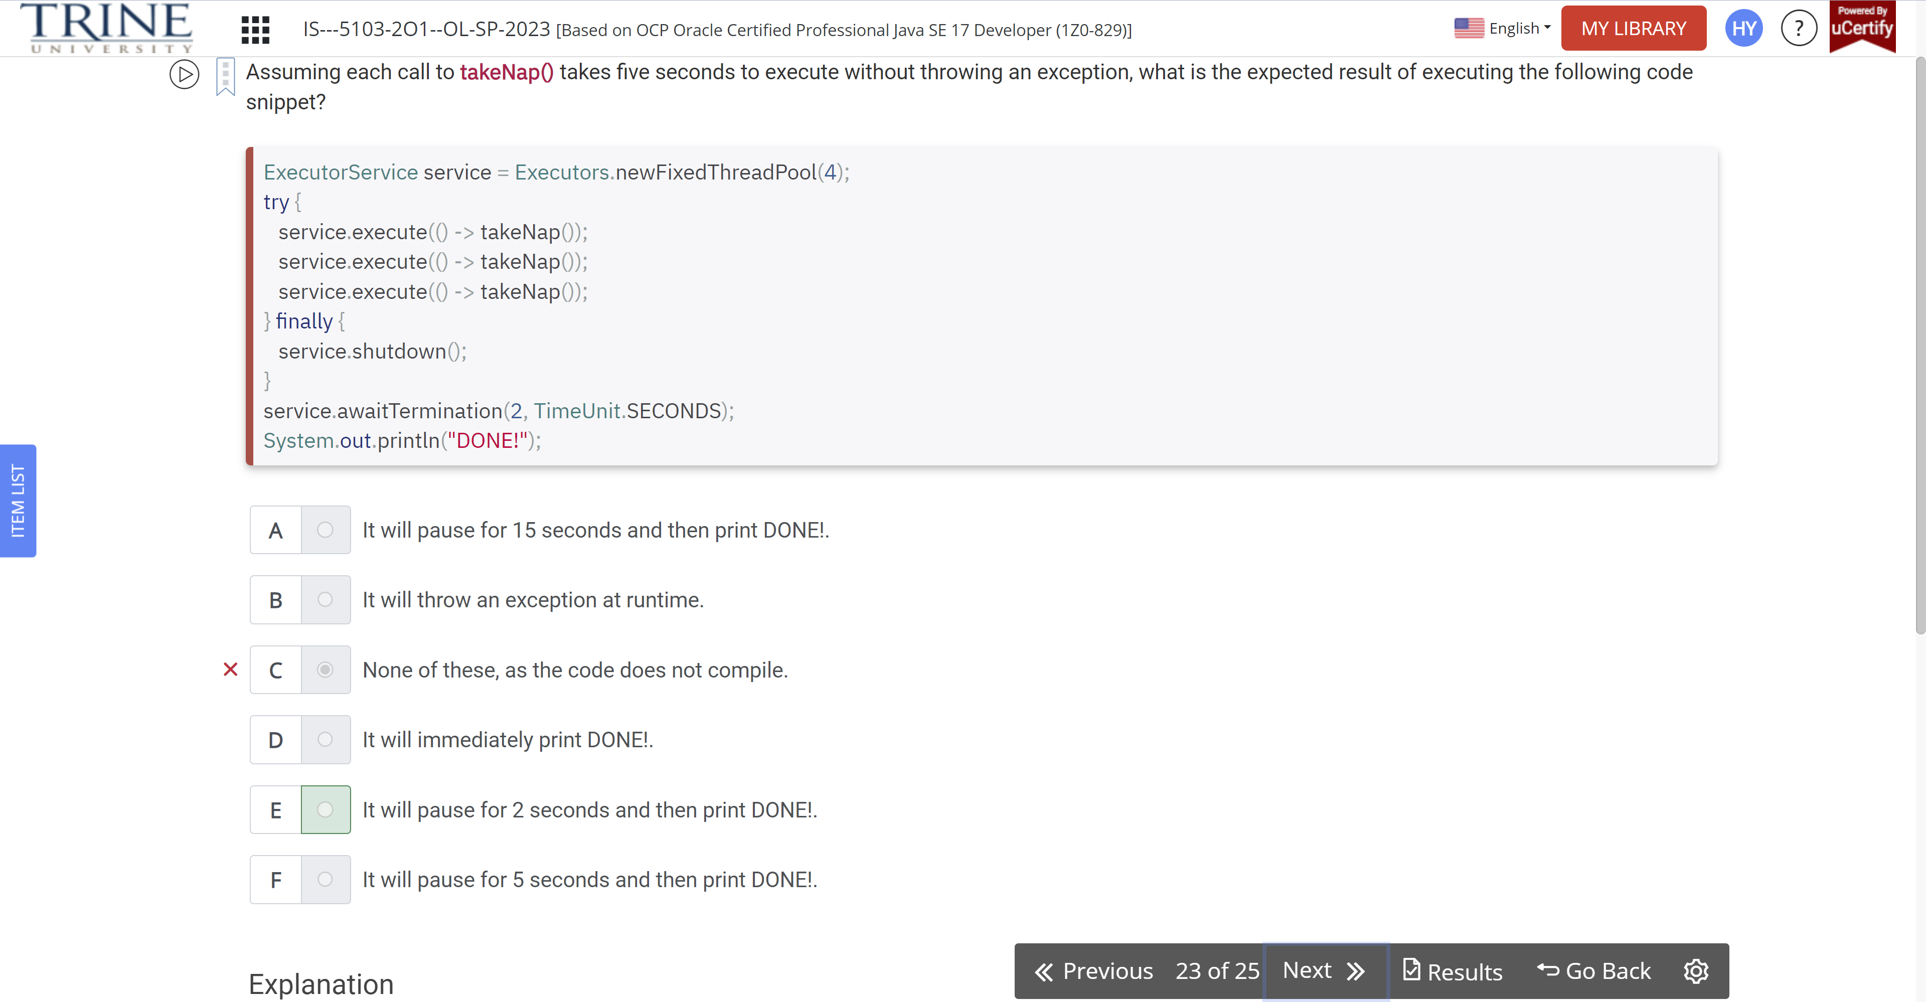

Assuming one minute is enough time for the tasks submitted to the service executor to complete, what is the result of executing countSheep()?

Public class BedTime…

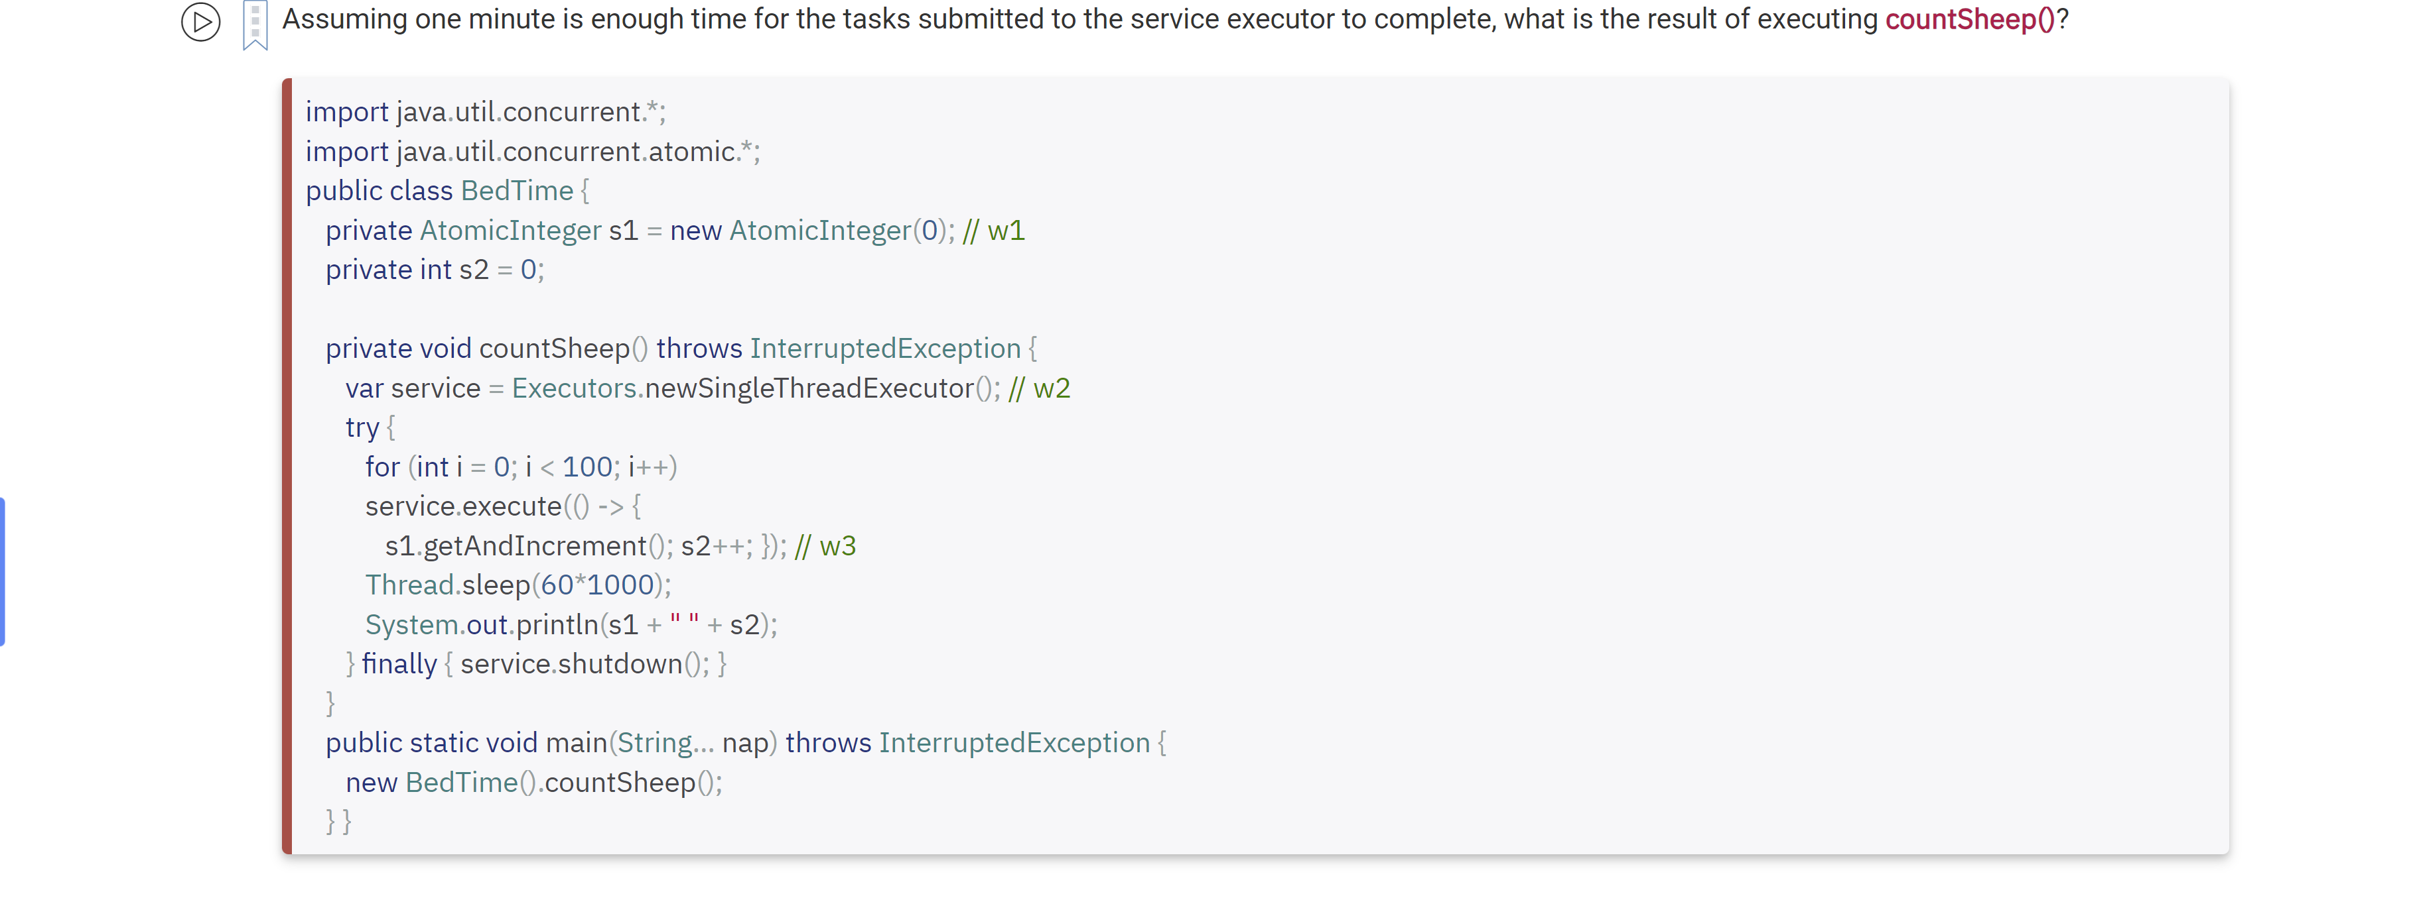

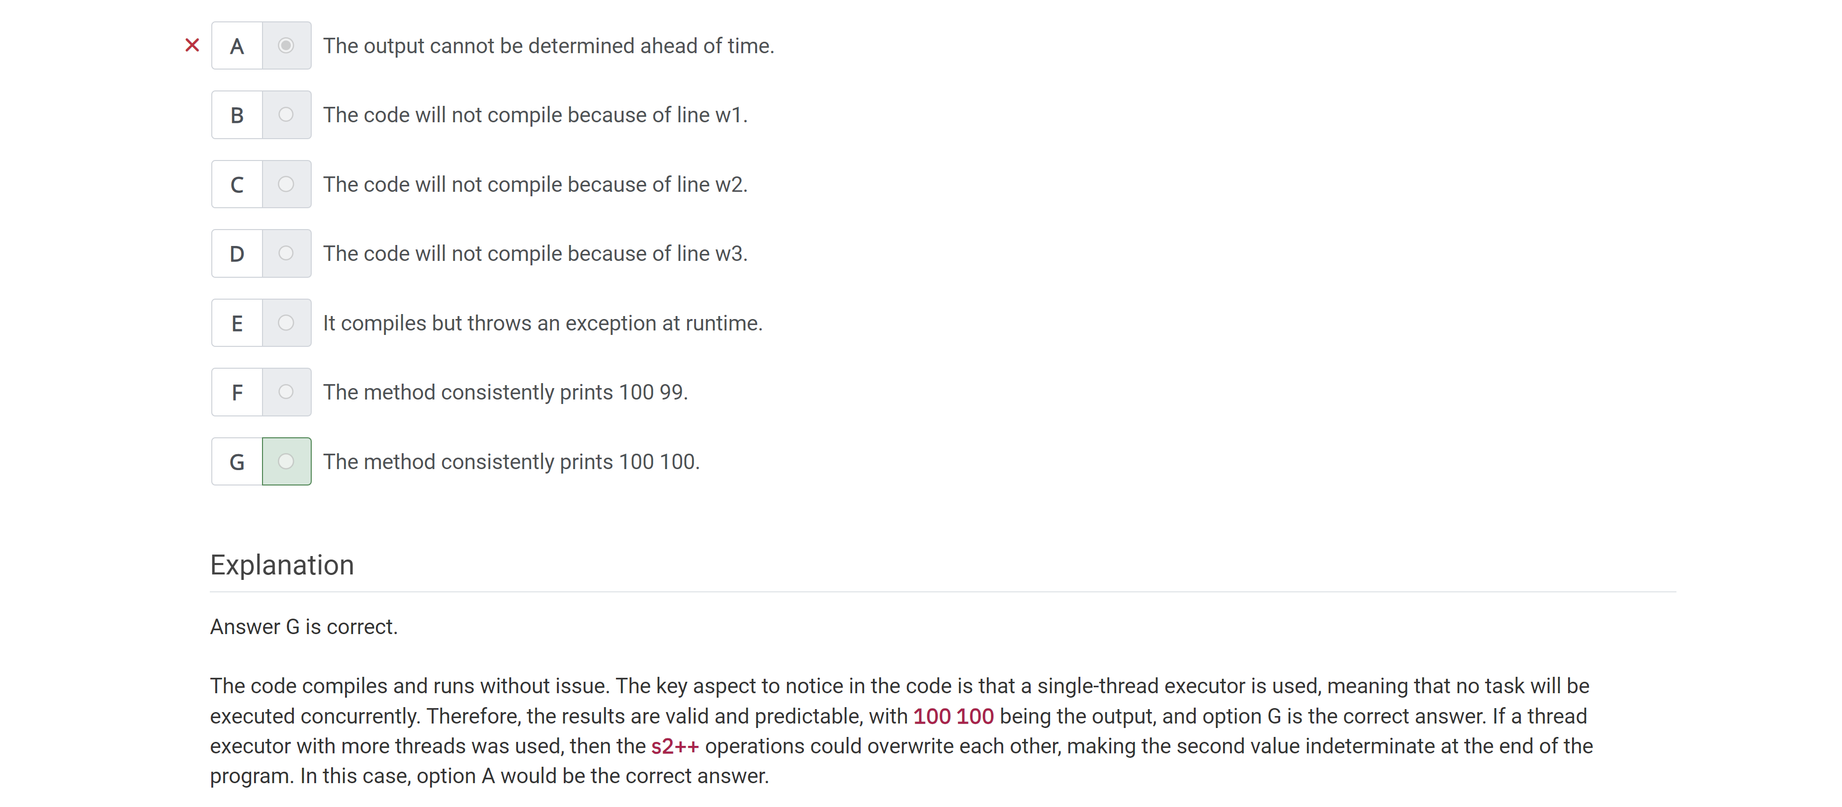

What statement about the following code is true?

Integer i1 = List.of(…)

